
COMSATS University Islamabad, Sahiwal Campus.

AI Enhanced Nutriculture

A project presented to
COMSATS University Islamabad, Sahiwal Campus

In partial fulfillment
of the requirement for the degree of

Bachelor of Science in Software Engineering (2022–2026)
By

Umer Saleem | CIIT/FA22-BSE-076/SWL
Muhammad Ali | CIIT/FA22-BSE-098/SWL
Samran Sohail | CIIT/FA22-BSE-093/SWL

Supervisor
Mr. Usman Nasir
Co-Supervisors: Mr. Bilal Shabbir

DECLARATION
We hereby declare that this software project, neither whole nor any part thereof, has been copied from any source without proper acknowledgement. It is further declared that we have developed this software and the accompanying report entirely on the basis of our personal efforts and original work. If any part of this project is proved to be copied from any source or found to be a reproduction of some other work, we shall stand by the consequences.

No portion of the work presented in this report has been submitted in support of any application for any other degree or qualification at this or any other university or institute of learning. This project titled "AI-Enhanced Nutriculture" is submitted in partial fulfillment of the requirements for the degree of Bachelor of Science in Software Engineering at COMSATS University Islamabad, Sahiwal Campus.

Umer Saleem Muhammad Ali Samran Sohail
CIIT/FA22-BSE-076/SWL CIIT/FA22-BSE-098/SWL CIIT/FA22-BSE-093/SWL

CERTIFICATE OF APPROVAL
It is hereby certified that the Final Year Project titled " AI-Enhanced Nutriculture" was developed by Umer Saleem (CIIT/FA22-BSE-076/SWL), Muhammd Ali (CIIT/FA22-BSE-098/SWL), and Samran Sohail (CIIT/FA22-BSE-093/SWL) under the supervision of Mr. Usman Nasir and co-supervision of Mr. Bilal Shabbir In their opinion, the project is fully adequate in scope and quality for the degree of Bachelor of Science in Software Engineering.

Supervisor: ___________________________
Mr. Usman Nasir

External Examiner: ___________________________

Head of Department: ___________________________
Department of Computer Science

Department of Computer Science
COMSATS University Islamabad, Sahiwal Campus
EXECUTIVE SUMMARY
The AI-Enhanced NutriCulture platform is a specialized, full-stack web application developed to bridge the critical gap between advanced health-tracking technology and traditional dietary habits. As lifestyle-related diseases such as Type 2 diabetes and cardiovascular conditions rise globally, digital health management has become essential. However, the current digital nutrition market is heavily Western-centric. Mainstream applications frequently fail to accurately track, analyze, or provide meaningful guidance for complex, multi-ingredient South Asian and Middle Eastern cuisines.
NutriCulture addresses this nutritional alienation by providing a culturally inclusive, intelligent platform tailored specifically to these underrepresented demographics. The system leverages an AI-as-a-Service (AIaaS) architecture to deliver culturally aware health support, empowering users to pursue their fitness and health goals without being forced to abandon their traditional food identities.
Core Capabilities and Innovations
The platform integrates several advanced AI modules and data-driven features to provide a seamless user experience:
- AI-Powered Food Recognition: Utilizing pretrained convolutional neural networks (CNNs), the platform allows users to upload images of complex regional dishes. The system instantly identifies the food and provides an accurate breakdown of calories, proteins, fats, and carbohydrates.
- Intelligent Meal Recommendations: A dynamic recommendation engine evaluates a user’s Body Mass Index (BMI), specific health objectives (e.g., weight loss, diabetes management), and cultural palate to generate highly personalized, culturally relevant weekly meal plans.
- Smart Ingredient Substitution: By integrating Large Language Models (LLMs), the platform acts as a digital nutritionist. It suggests healthier or allergy-friendly alternatives for traditional recipes (such as swapping heavy creams for specific low-fat regional alternatives) and explains the nutritional reasoning behind the swap.
- Real-Time Recipe Customization: Users can dynamically modify ingredient quantities within traditional dishes and instantly view the updated caloric and nutritional load, granting them total control over their portion sizing.
Technical Architecture
The project was developed following the Object-Oriented Methodology (OOM) to ensure a highly modular, maintainable, and scalable system. NutriCulture operates on a modern N-tier architecture:
- Frontend: Built with Next.js, TypeScript, and Tailwind CSS to ensure a responsive, accessible, and culturally intuitive user interface across all devices.
- Backend & Database: Powered by a Node.js environment utilizing Express.js. Relational data management is handled via MySQL and Prisma ORM, ensuring the secure, type-safe processing of sensitive user health metrics and comprehensive recipe libraries.
- Security: Implements rigorous security protocols, including JSON Web Token (JWT) session management and Bcrypt password hashing, ensuring full protection of user data.
Project Impact
NutriCulture successfully demonstrates that effective health technology requires cultural contextualization. By equipping users with the tools to intelligently modify, track, and understand their traditional diets, the platform promotes sustainable, long-term health outcomes. It provides a vital resource for communities that have been historically underserved by the global digital fitness industry, proving that cultural heritage and modern nutritional science can coexist seamlessly.

ACKNOWLEDGEMENT
All praise and gratitude is due to Almighty Allah, whose boundless mercy and guidance made the completion of this project possible. It is by His grace alone that we were granted the knowledge, perseverance, and strength to undertake and successfully complete this academic endeavor.
We express our deepest and most sincere gratitude to our project supervisor, Mr. Fahad Ameen, whose consistent mentorship, technical guidance, and academic insight were instrumental at every stage of this project. His constructive feedback, timely reviews, and unwavering commitment to quality significantly elevated the standard of our work. We are equally grateful to our co-supervisors, Mr. Ahmad Shaf and Ms. Hafsa Saleem, whose technical reviews and design evaluations provided invaluable direction during critical phases of development.
We extend our heartfelt thanks to the faculty of the Department of Computer Science at COMSATS University Islamabad, Sahiwal Campus, whose academic instruction over four years provided the theoretical and practical foundation upon which this project was built. The knowledge gained through courses in software engineering, database systems, mobile application development, and data analytics proved directly applicable to the challenges encountered during this project.
Our sincere appreciation also goes to the shopkeepers and small business owners in Sahiwal who participated in our initial data gathering and user feedback sessions. Their practical insights into the real-world challenges of manual record-keeping and billing provided the contextual grounding that shaped the requirements and design of AI-Enhanced Nutriculture. Finally, we are deeply grateful to our families for their unwavering support, patience, and encouragement throughout the demanding journey of this final year project.

Umer Saleem Muhammad Umer Samran Sohail

ABBREVIATIONS
Abbreviation | Full Form
API | Application Programming Interface
CRUD | Create, Read, Update, Delete
DAO | Data Access Object
DFD | Data Flow Diagram
ETL | Extract, Transform, Load
FBR | Federal Board of Revenue
FYP | Final Year Project
HTTPS | Hypertext Transfer Protocol Secure
JWT | JSON Web Token
KPI | Key Performance Indicator
MVVM | Model View ViewModel
OOD | Object-Oriented Design
OOP | Object-Oriented Programming
POS | Point of Sale
RBAC | Role-Based Access Control
REST | Representational State Transfer
RTM | Requirements Traceability Matrix
SDD | Software Design Document
SDLC | Software Development Life Cycle
SME | Small and Medium Enterprise
SMEDA | Small and Medium Enterprises Development Authority
SMS | Short Message Service
SRS | Software Requirements Specification
UI | User Interface
UML | Unified Modeling Language
UX | User Experience

Table of Contents
Chapter 1 Introduction 14
1.1 Brief 15
1.2 Relevance to Course Modules 15
1.3 Project Background 16
1.4 Literature Review 16
1.5 Analysis from Literature Review 17
1.6 Methodology and Software Lifecycle 17
1.6.1 Rationale behind Selected Methodology 17
Chapter 2 Problem Definition 18
2.1 Problem Statement 19
2.1.1 The Cultural Data Gap 19
2.1.2 The Technological Recognition Failure 19
2.1.3 The Psychological Barrier to Health 20
2.2 Deliverables and Development Requirements 20
2.2.1 Software Deliverables 20
2.2.2 Documentation Deliverables 20
2.3 Current System Analysis 21
2.3.1 Manual Tracking (The Traditional Method) 21
2.3.2 Competitor Analysis: Western Apps 21
Chapter 3 Requirement Analysis 22
3.1 Use Cases Diagram 23
3.1.1 Identification of Actors 25
3.1.2 Scope of Interactions 25
3.2 Use Case Descriptions 25
3.3 Functional Requirements 37
3.3.1 User Registration 37
3.3.2 User Login 38
3.3.3 User Registration 39
3.3.4 AI Meal Suggestion 40
3.3.5 AI Recommender Integration 41
3.3.6 Ingredient Substitution 42
3.3.7 Recipe Customization 43
3.3.8 Recipe Search & Filtering 44
3.3.9 BMI Calculation 45
3.3.10 Image-Based Nutrition Analysis 46
3.3.11 Admin Monitoring 47
3.4 Non-Functional Requirements 47
3.4.1 Usability 48
3.4.2 Performance 48
Chapter 4 Design and Architecture 49
4.1 System Architecture 51
4.1.1 The Full-Stack Framework 52
4.1.2 AI Service Integration Layer 53
4.2 Data Representation 55
4.2.1 Relational Database Model 55
4.2.2 Key Entities and Attributes 56
4.3 Process Flow and Representation 58
4.3.1 The Nutrition Analysis Lifecycle 58
4.4 Design Models 64
4.4.1 Modularity through OOM 64
4.5 Activity Diagram 65
4.5 Sequence Diagrams. 66
Chapter 5 IMPLEMENTATION 68
5.1 Algorithm Development 69
5.1.1 Body Mass Index (BMI) and Goal Mapping Algorithm 69
5.1.2 Image-to-Nutrition Inference Logic 69
5.1.3 Recommendation Engine (Content-Based Filtering) 70
5.2 External APIs and Integration 70
5.2.1 Nutritionix API 70
5.2.2 Google Cloud Vision / Food-101 Based APIs 70
5.2.3 OpenAI GPT-4 API 70
5.3 User Interface Implementation 71
5.3.1 The Dashboard 71
5.3.2 Recipe Explorer and Filters 71
5.3.3 The Meal Planner Interface 71
5.4 Backend Logic and Security Implementation 72
5.4.1 Security and Authentication (JWT) 72
5.4.2 Request Handling and Middleware 72
5.5 Database Management and Schema Design 73
5.5.1 Neon ORM Integration 74
5.5.2 Data Modeling and Relationships 74
5.6 API Orchestration and Data Interchange 75
5.6.1 Standardizing with Axios and JSON 75
5.6.2 External API Lifecycle and Error Handling 76
Chapter 6 TESTING AND EVALUATION 77
6.1 Manual Testing 78
6.1.1 TEST CASES FOR UI NAVIGATION 78
6.1.2 TEST CASES FOR RESPONSIVE DESIGN (MOBILE) 79
6.1.3 TEST CASES FOR FORM ACCESSIBILITY 79
6.1.4 TEST CASES FOR MANUAL IMAGE UPLOAD 80
6.1.5 TEST CASES FOR ERROR STATE UI 80
6.1.6 TEST CASES FOR COLOR CONTRAST 81
6.1.7 TEST CASES FOR MEAL PLANNER DRAG-AND-DROP 81
6.1.8 TEST CASES FOR LOGOUT BEHAVIOR 82
6.1.9 TEST CASES FOR DARK MODE TOGGLE 82
6.1.10 TEST CASES FOR RECIPE MODAL CLOSE 83
6.2 System Testing 84
6.2.1 TEST CASES FOR END-TO-END REGISTRATION TO PLANNER 84
6.2.2 TEST CASES FOR CONCURRENT LOGINS 85
6.2.3 TEST CASES FOR LARGE FILE UPLOADS 85
6.2.4 TEST CASES FOR API RATE LIMITING 86
6.2.5 TEST CASES FOR CROSS-BROWSER COMPATIBILITY 86
6.2.6 TEST CASES FOR DATABASE FAILOVER 87
6.2.7 TEST CASES FOR COLD START PERFORMANCE 87
6.2.8 TEST CASES FOR XSS VULNERABILITY 88
6.2.9 TEST CASES FOR JWT EXPIRATION 88
6.2.10 TEST CASES FOR DATA PURGE (GDPR COMPLIANCE) 89
6.3 Unit Testing 90
6.3.1 TEST CASES FOR BMI ALGORITHM 90
6.3.2 TEST CASES FOR PASSWORD HASHING 91
6.3.3 TEST CASES FOR EMAIL VALIDATION REGEX 91
6.3.4 TEST CASES FOR INGREDIENT PARSER 92
6.3.5 TEST CASES FOR JWT GENERATOR 92
6.3.6 TEST CASES FOR CALORIE AGGREGATOR 93
6.3.7 TEST CASES FOR DATE FORMATTER 94
6.3.8 TEST CASES FOR ARRAY SHUFFLER 94
6.3.9 TEST CASES FOR MACRO PERCENTAGE CALCULATOR 95
6.3.10 TEST CASES FOR NULL VALUE SANITIZER 95
6.4 Functional Testing 96
6.4.1 TEST CASES FOR RECIPE FILTERING BY CUISINE 96
6.4.2 TEST CASES FOR SAVE MEAL PLAN 96
6.4.3 TEST CASES FOR INGREDIENT SUBSTITUTION 97
6.4.4 TEST CASES FOR PROFILE UPDATES 97
6.4.5 TEST CASES FOR RECIPE FAVORITING 98
6.4.6 TEST CASES FOR SEARCH BY INGREDIENT 98
6.4.7 TEST CASES FOR AUTO-GENERATE MEAL PLAN 99
6.4.8 TEST CASES FOR PASSWORD RESET 99
6.4.9 TEST CASES FOR RECIPE NUTRITION UPDATER 100
6.4.10 TEST CASES FOR ADMIN LOGIN 100
6.5 Integration Testing 101
6.5.1 TEST CASES FOR FRONTEND TO BACKEND API 101
6.5.2 TEST CASES FOR BACKEND TO DATABASE ORM 101
6.5.3 TEST CASES FOR GOOGLE VISION API INTEGRATION 102
6.5.4 TEST CASES FOR NUTRITIONIX API INTEGRATION 103
6.5.5 TEST CASES FOR OPENAI GPT INTEGRATION 103
6.5.6 TEST CASES FOR TOKEN ATTACHMENT IN HEADERS 104
6.5.7 TEST CASES FOR MEAL PLAN AND RECIPE JOIN 105
6.5.8 TEST CASES FOR REGISTRATION TO EMAIL MOCK 105
6.5.9 TEST CASES FOR IMAGE TO DB LOGGING 106
6.5.10 TEST CASES FOR DASHBOARD AGGREGATION 107
Chapter 7 CONCLUSION AND FUTURE WORK 108
7.1 Conclusion 109
7.2 Future Work 110
7.2.1 Native Mobile Application Development 110
7.2.2 Expansion of Cultural Datasets 110
7.2.3 Integration with Wearable Health Devices 110
7.2.4 Transition to Custom Fine-Tuned Local Models 110
7.2.5 Community and Social Sharing Features 110
References 111

List of Tables

Table 1 Related System Analysis / Literature Review 16
Table 2 Use Case 1: Upload Food Image for Nutrition Analysis 25
Table 3 Use Case 2: User Registration and Login 27
Table 4 Use Case 3: AI-Assisted Meal Planner 29
Table 5 Use Case 4: AI Meal Recommender 31
Table 6 Use Case 5: Ingredient Substitution Generator 32
Table 7 Use Case 6: Health-Aware Recipe Customizer 33
Table 8 Use Case 7: Recipe Explorer 34
Table 9 Use Case 8: BMI Calculator 35
Table 10 Use Case 9: Admin Monitoring & Moderation 36
Table 11 Functional Requirement 1: User Registration 37
Table 12 Functional Requirement 2: User Login 38
Table 13 Functional Requirement 3: Meal Plan Creation 39
Table 14 Functional Requirement 4: AI Meal Suggestion 40
Table 15 Functional Requirement 5: AI Recommender Integration 41
Table 16 Functional Requirement 6: Ingredient Substitution 42
Table 17 Functional Requirement 7: Recipe Customization 43
Table 18 Functional Requirement 8: Recipe Search & Filtering 44
Table 19 Functional Requirement 9: BMI Calculation 45
Table 20 Functional Requirement 10: Image-Based Nutrition Analysis 46
Table 21 Functional Requirement 11: Admin Monitoring 47
Table 22 TEST CASES FOR UI NAVIGATION 78
Table 23 TEST CASES FOR RESPONSIVE DESIGN 79
Table 24 TEST CASES FOR FORM ACCESSIBILITY 79
Table 25 TEST CASES FOR MANUAL IMAGE UPLOAD 80
Table 26 TEST CASES FOR ERROR STATE UI 80
Table 27 TEST CASES FOR COLOR CONTRAST 81
Table 28 TEST CASES FOR MEAL PLANNER DRAG-AND-DROP 81
Table 29 TEST CASES FOR LOGOUT BEHAVIOR 82
Table 30 TEST CASES FOR DARK MODE TOGGLE 82
Table 31 TEST CASES FOR RECIPE MODAL CLOSE 83
Table 32 TEST CASES FOR E2E USER JOURNEY 84
Table 33 TEST CASES FOR CONCURRENT LOGINS 85
Table 34 TEST CASES FOR LARGE FILE UPLOADS 85
Table 35 TEST CASES FOR API RATE LIMITING 86
Table 36 TEST CASES FOR CROSS-BROWSER COMPATIBILITY 86
Table 37 TEST CASES FOR DATABASE FAILOVER 87
Table 38 TEST CASES FOR COLD START PERFORMANCE 87
Table 39 TEST CASES FOR XSS VULNERABILITY 88
Table 40 TEST CASES FOR JWT EXPIRATION 88
Table 41 TEST CASES FOR DATA PURGE 89
Table 42 TEST CASES FOR BMI ALGORITHM 90
Table 43 TEST CASES FOR PASSWORD HASHING 91
Table 44 TEST CASES FOR EMAIL VALIDATION 91
Table 45 TEST CASES FOR INGREDIENT PARSER 92
Table 46 TEST CASES FOR JWT GENERATOR 92
Table 47 TEST CASES FOR CALORIE AGGREGATOR 93
Table 48 TEST CASES FOR DATE FORMATTER 94
Table 49 TEST CASES FOR ARRAY SHUFFLER 94
Table 50 TEST CASES FOR MACRO PERCENTAGE CALCULATOR 95
Table 51 TEST CASES FOR NULL VALUE SANITIZER 95
Table 52 TEST CASES FOR RECIPE FILTERING 96
Table 53 TEST CASES FOR SAVE MEAL PLAN 96
Table 54 TEST CASES FOR INGREDIENT SUBSTITUTION 97
Table 55 TEST CASES FOR PROFILE UPDATES 97
Table 56 TEST CASES FOR RECIPE FAVORITING 98
Table 57 TEST CASES FOR SEARCH BY INGREDIENT 98
Table 58 TEST CASES FOR AUTO-GENERATE MEAL PLAN 99
Table 59 TEST CASES FOR PASSWORD RESET 99
Table 60 TEST CASES FOR RECIPE NUTRITION UPDATER 100
Table 61 TEST CASES FOR ADMIN LOGIN 100
Table 62 TEST CASES FOR FRONTEND TO BACKEND API 101
Table 63 TEST CASES FOR BACKEND TO DATABASE ORM 101
Table 64 TEST CASES FOR GOOGLE VISION API INTEGRATION 102
Table 65 TEST CASES FOR NUTRITIONIX API INTEGRATION 103
Table 66 TEST CASES FOR OPENAI GPT INTEGRATION 103
Table 67 TEST CASES FOR TOKEN ATTACHMENT 104
Table 68 TEST CASES FOR DATABASE JOINS 105
Table 69 TEST CASES FOR NOTIFICATION PIPELINE 105
Table 70 TEST CASES FOR IMAGE ANALYSIS LOGGING 106
Table 71 TEST CASES FOR DASHBOARD AGGREGATION 107

List of Figures
Figure 1 Use Case Diagram 25
Figure 2 OOP Principles in Nutriculture 51
Figure 3 Architecture Diagram 52
Figure 4 Frontend Structure 53
Figure 5 Backend Structure 54
Figure 6 AI Workflow Diagram 56
Figure 7 Relational Database Diagram 57
Figure 8 Entity Relationship Diagram ERD 58
Figure 9 Process Flow Diagram 59
Figure 10 Nutrition Lifecycle Flowchart 60
Figure 11 Nutrition Analysis Flowchart 61
Figure 12 API Orchestration Flowchart 62
Figure 13 System Development Lifecycle 64
Figure 14 Frontend Workflow diagram 65
Figure 15 Activity Diagram 67
Figure 16 Sequence Diagram 68
Figure 17 Data flow Diagram 68
Figure 18 Process Data visual Diagram . 69
Figure 19 Database Schema 75
Figure 20 Data Modeling 76
Figure 21 External API Lifecycle and Error Handling 78

Chapter 1
Introduction

1.1 Brief
AI-Enhanced NutriCulture is a specialized, full-stack web application designed to bridge the gap between advanced health-tracking technology and cultural dietary habits. While the global fitness market is saturated with nutrition applications, most platforms suffer from a significant "Western bias," failing to accurately recognize or analyze the caloric density and nutritional complexity of traditional ethnic cuisines.
NutriCulture addresses this by providing a culturally aware environment specifically tailored for South Asian and Middle Eastern users. The platform utilizes Artificial Intelligence (AI) for food image recognition, personalized meal planning, and intelligent ingredient substitution, allowing users to pursue health goals like weight loss or diabetes management without sacrificing their cultural identity

1.2 Relevance to Course Modules
This Final Year Project (FYP) represents the culmination of the Bachelor of Science in Software Engineeringcurriculum (2022–2026). It serves as a practical implementation of several core academic modules:
- Software Requirement Engineering: The foundation of the project was built upon identifying complex user needs and documenting them through the Software Requirement Specification (SRS).
- Artificial Intelligence & Machine Learning: The system integrates Convolutional Neural Networks (CNN) for image classification and Large Language Models (LLMs) for personalized recommendations.
- Web Engineering: Developed using a modern stack including Next.js, TypeScript, and Tailwind CSS to ensure a responsive, high-performance user experience.
- Database Systems: The project utilizes MySQL with Prisma ORM for structured, relational data management and efficient schema modeling.
- Human-Computer Interaction (HCI): The interface is designed to be culturally inclusive and intuitive, reducing cognitive load for users from diverse backgrounds.

1.3 Project Background
The motivation for NutriCulture stems from a growing health crisis in the South Asian and Middle Eastern regions, where lifestyle-related diseases such as Type 2 diabetes and hypertension are on the rise. Traditional diets in these regions often involve complex, multi-ingredient dishes (e.g., Biryani, Nihari, Kebabs) that are difficult to track in conventional apps.
Current solutions often leave users with two undesirable choices: either abandon their traditional food in favor of "Westernized" healthy options or continue eating traditional meals without any accurate way to monitor their nutritional intake. NutriCulture was developed at COMSATS University Islamabad, Sahiwal Campus, to provide a third option—empowering users to modify their traditional recipes for better health.

1.4 Literature Review
A comparative study was conducted to evaluate the efficacy of existing nutrition platforms. The following table summarizes the limitations identified in current market leaders compared to the proposed NutriCulture solution:

Table 1 Related System Analysis / Literature Review
Application Name | Key Weaknesses | NutriCulture Solution
MyFitnessPal | Primary focus on Western food; lacks data for regional ethnic dishes. | Deep support for South Asian and Middle Eastern cuisine datasets.
Yummly | Does not offer regional diet advice or culturally specific substitutions. | Offers culturally-relevant healthy recipe swaps and ingredient alternatives.
CalorieMama | Low accuracy in recognizing complex ethnic food images. | Uses specialized AI models for high-accuracy recognition of "desi" dishes.

1.5 Analysis from Literature Review
The literature review confirms a significant "cultural gap" in the digital health industry. Most mainstream apps generalize health content, which leads to a lack of trust and engagement among non-Western users.
Key findings include:
- Data Scarcity: There is a lack of verified nutritional data for home-cooked traditional meals compared to processed Western foods.
- Technological Limitation: Standard image recognition models often confuse different types of curries or gravies due to similar visual textures.
- The Need for Personalization: Users are more likely to adhere to a diet if it respects their palate and religious or cultural restrictions (e.g., Halal requirements).

1.6 Methodology and Software Lifecycle
The project adopts the Object-Oriented Methodology (OOM) for the entirety of its development lifecycle. This approach models the system as a collection of modular, interacting objects—such as User Profiles, Recipes, and AI Analyzers—ensuring that each component is maintainable and scalable.

1.6.1 Rationale behind Selected Methodology
The selection of OOM was driven by the following technical requirements:
- Modularity: Given the complexity of integrating external AI-as-a-Service APIs, OOM allows for isolated logic within specific modules (e.g., Module 4: Nutrition Analyzer).
- Code Reuse: Relational database modeling with Prisma ORM integrates seamlessly with object-oriented design patterns, allowing for efficient data handling
- Scalability: The modular nature of OOM makes it easier to expand the platform in the future, such as adding new regional cuisines or additional AI features, without restructuring the core architecture.
- Collaborative Efficiency: The team can work concurrently on different "objects" or modules—such as Samran Sohail focusing on the Meal Planner while Umer Saleem develops the Nutrition Analyzer—minimizing integration conflicts.

Chapter 2
Problem Definition

Definition
The definition of the problem is the most critical phase of the NutriCulture project, as it identifies the specific gap between current technological capabilities and the unique needs of the South Asian and Middle Eastern populations. This chapter explores the systemic issues within the digital health industry and why a specialized solution is no longer just a luxury, but a necessity for public health.

2.1 Problem Statement
The primary challenge addressed by NutriCulture is the nutritional alienation caused by the "Western-centric" nature of existing health and fitness applications. While the global market for diet tracking is worth billions, it largely ignores the dietary realities of over two billion people living in or originating from the South Asian and Middle Eastern regions.

2.1.1 The Cultural Data Gap
Mainstream applications like MyFitnessPal and Yummly rely on databases that prioritize processed Western foods and simple, single-ingredient meals. Traditional South Asian and Middle Eastern cuisines are fundamentally different. They are characterized by:
- Complex Ingredient Lists: A single curry may contain over 20 different spices, oils, and base vegetables, making manual entry nearly impossible for the average user.
- Variable Cooking Methods: The nutritional profile of a dish like Palak Paneer or Kebab changes drastically based on whether it is shallow-fried, deep-fried, or grilled—details standard apps often overlook.
- Communal Eating Patterns: Regional meals are often served family-style, making portion control and calorie estimation difficult without specialized tools.

2.1.2 The Technological Recognition Failure
Current food recognition technologies, built on general-purpose datasets like ImageNet, often fail to distinguish between various types of ethnic "gravy" dishes. For example, an AI might correctly identify "stew," but fail to differentiate between a high-protein lentil Daal and a high-fat Nihari. This lack of accuracy leads to incorrect nutritional tracking, which can be dangerous for users managing chronic conditions like diabetes or hypertension.

2.1.3 The Psychological Barrier to Health
When users are told by an app that their traditional food is "unhealthy" or "untraceable" they often experience a psychological disconnect. This leads to a cycle of nutritional abandonment, where users stop tracking altogether because they feel they must choose between their heritage and their health. NutriCulture aims to break this cycle by providing a platform that understands and validates their cultural food identity.

2.2 Deliverables and Development Requirements
To solve these problems, the project is structured to provide a comprehensive ecosystem of digital tools and documentation. The following deliverables ensure the system is functional, documented, and ready for deployment.

2.2.1 Software Deliverables
- The NutriCulture Web Portal: A responsive, full-stack application built using Next.js and TypeScript, serving as the primary interface for users.
- AI Nutrition Analyzer: A specialized module capable of processing food images and returning accurate nutritional breakdowns.
- Meal Recommendation Engine: A logic-based system that suggests healthy alternatives tailored to the user's specific cultural preferences and BMI category.
- Integrated Database: A robust MySQL database managed via Prisma ORM, containing a curated library of regional recipes and user health data.

2.2.2 Documentation Deliverables
- Software Requirement Specification (SRS): A detailed document outlining every functional and non-functional requirement.
- System Design Document (SDD): High-level and low-level architectural diagrams, including UML Use Case, Class, and Sequence diagrams.
- Testing and Validation Report: Comprehensive logs of unit, integration, and user acceptance testing (UAT).

2.3 Current System Analysis
Before developing NutriCulture, an in-depth analysis of "Current Systems" (the status quo) was conducted. This involves looking at how users currently manage their nutrition and where these methods fail.

2.3.1 Manual Tracking (The Traditional Method)
Many health-conscious individuals in the region currently use manual calorie counting books or general web searches. This method is:
- Time-Consuming: Requires users to manually weigh ingredients before cooking.
- Inaccurate: Leads to "estimation bias," where users under-report calorie intake by as much as 30%.
- Inconsistent: Lacks the ability to track progress over weeks or months.

2.3.2 Competitor Analysis: Western Apps
Existing apps are the "Current System" for those who have tried digital tracking. However, as noted in the Literature Review, these systems suffer from:
- Limited Databases: Most ethnic dishes are either missing or have "placeholder" values that do not reflect actual local recipes.
- Lack of Specificity: They do not account for the high use of Ghee (clarified butter) or specific regional oils that drastically alter caloric density.
- Non-Inclusive UX: Interfaces are rarely translated or optimized for the cultural nuances of the South Asian and Middle Eastern diaspora.

Chapter 3
Requirement Analysis

The requirement analysis phase is the most critical juncture in the Software Development Life Cycle (SDLC) for NutriCulture. In this phase, the abstract goals defined in the previous chapters are translated into concrete, actionable specifications. This chapter provides a detailed examination of the system's behavioral model through Use Case modeling and a comprehensive breakdown of both functional and non-functional requirements.

3.1 Use Cases Diagram
To model the behavior of the AI-Enhanced NutriCulture system, we utilize the Use Case technique. This method allows us to visualize the interactions between the system and its external entities, ensuring that every user-system interaction produces a meaningful result.
The Use Case Diagram for NutriCulture visually represents the interactions between users (actors) and the system’s core functionalities.
- Primary Actor:
- Registered User
- Secondary Actors:
- AI API Service (Pretrained Model APIs)
- Database System
- Main Use Cases:
- Register / Log In
- Manage User Profile and Preferences
- View and Search Recipes
- Generate Healthy Meal Plan
- Upload Food Image for Nutrition Analysis
- Get AI-Generated Meal Recommendations
- View Ingredient Substitutions
- Calculate BMI

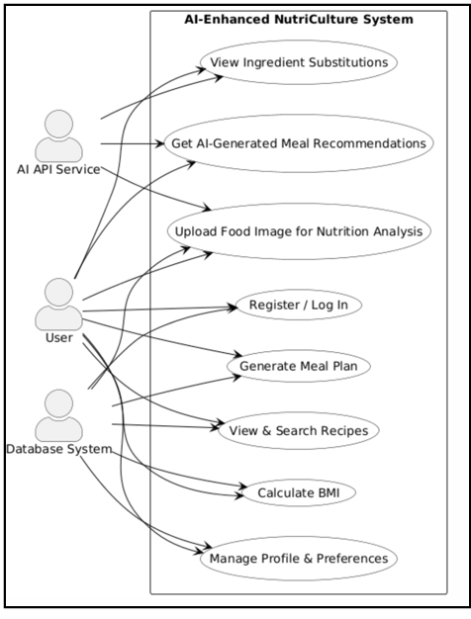
Figure 1 Use Case Diagram

3.1.1 Identification of Actors
The system interacts with several distinct entities, classified as primary and secondary actors:
- Primary Actor: Registered User: The individual seeking nutritional guidance, who interacts with the system to track meals, get recommendations, and calculate health metrics.
- Secondary Actor: AI API Service: External pretrained model APIs that provide the "intelligence" for image recognition, recommendation logic, and ingredient analysis.
- Secondary Actor: Database System: The persistent storage layer that manages user profiles, recipe libraries, and historical data.
- Secondary Actor: Administrator: A specialized user responsible for monitoring system analytics and moderating content.

3.1.2 Scope of Interactions
The core functionalities modeled in our use case diagrams include user authentication, profile management, recipe discovery, AI-assisted meal planning, and automated nutrition analysis through image processing .

3.2 Use Case Descriptions

Table 2 Use Case 1: Upload Food Image for Nutrition Analysis
Attribute | Details
Use Case ID | UC1
Use Case Name | Upload Food Image for Nutrition Analysis
Actor(s) | User
Description | The user uploads an image of a traditional dish. The system sends this image to a pretrained AI image-recognition API integrated through the backend. The API returns the detected dish name and nutritional values (calories, protein, fat, carbs), which are then displayed to the user.
Preconditions | PRE-1: User must be logged in.  PRE-2: User must have a stable internet connection.
Trigger | The user clicks on “Upload Food Image” within the dashboard.
Postconditions | POST-1: Nutritional values of the uploaded food are displayed on screen.  POST-2: The analysis record is stored in the user’s history.
Normal Flow | 1. User navigates to the “Nutrition Analyzer” section.  2. User selects and uploads a food image.  3. System sends the image to the backend.  4. Backend calls the pretrained AI API for recognition.  5. API returns dish name and nutrition data.  6. System displays the analysis to the user.
Assumptions | A1: Pretrained AI API has sufficient accuracy for ethnic dish recognition.

Table 3 Use Case 2: User Registration and Login
Attribute | Details
Use Case ID | UC2
Use Case Name | User Registration and Login
Actor(s) | Primary Actor: User  Secondary Actor: Database System
Description | This use case allows a new user to create an account or an existing user to log in. The system securely stores user credentials in the database and authenticates access using email and password. Once authenticated, the user can access all personalized modules such as the meal planner and nutrition analyzer.
Preconditions | PRE-1: The system must be running and connected to the database.  PRE-2: The user has a valid internet connection.
Trigger | The user selects “Sign Up” or “Log In” from the homepage.
Postconditions | POST-1: New users have a registered account with stored profile data.  POST-2: Authenticated users gain access to the main dashboard.
Normal Flow | 1. User clicks Sign Up / Log In.  2. System displays the authentication form.  3. User enters email and password (and other required fields during sign-up).  4. System validates input format.  5. For sign-up → system creates a new user record in the database.  6. For login → system verifies credentials from stored records.  7. If valid, system generates a secure session/token.  8. System redirects user to the main dashboard.
Assumptions | A1: User provides valid contact information.  A2: Session tokens expire automatically after a predefined period of inactivity.

Table 4 Use Case 3: AI-Assisted Meal Planner
Attribute | Details
Use Case ID | UC3
Use Case Name | AI-Assisted Meal Planner
Actor(s) | Primary Actor: User  Secondary Actors: Database System, AI API Service
Description | This use case allows users to create weekly meal plans based on their health goals and cuisine preferences. The system retrieves culturally relevant recipes from the database and uses a pretrained recommendation API to suggest healthy meal combinations. Users can view, edit, and save their weekly meal plan for easy tracking.
Preconditions | PRE-1: The user must be logged in.  PRE-2: The system must have access to the recipe and nutritional database.
Trigger | The user navigates to the “Meal Planner” section and selects the option to generate or edit a plan.
Postconditions | POST-1: A new meal plan is generated and saved to the user’s account.  POST-2: The user can view or modify the meal plan later.
Normal Flow | 1. User opens the “Meal Planner” page.  2. System displays an empty weekly planner grid.  3. User selects dietary goals (e.g., weight loss, diabetes management).  4. System requests AI API to recommend suitable meals based on preferences.  5. The system displays suggested breakfast, lunch, and dinner for each day.  6. User reviews and customizes meals (add/remove dishes).  7. User saves the final plan.  8. System stores the plan and updates total calories/nutrition summary.
Assumptions | A1: AI API provides meal suggestions aligned with user-defined preferences.  A2: Nutritional data for all listed recipes exists in the database.

Table 5 Use Case 4: AI Meal Recommender
Attribute | Details
Use Case ID | UC4
Use Case Name | AI Meal Recommender
Actor(s) | Primary Actor: User  Secondary Actor: AI API Service
Description | The user requests AI-generated personalized meal suggestions. The system sends user profile data (health goals, allergies, cuisine preferences) to a pretrained recommendation API, which returns healthy and culturally relevant dishes.
Preconditions | PRE-1: User must be logged in. PRE-2: User profile must contain at least one health goal and preferred cuisine.
Trigger | User clicks “Get Meal Recommendations” on the dashboard.
Postconditions | POST-1: Recommended meals are displayed on screen. POST-2: User can save preferred suggestions to favorites or meal planner.
Normal Flow | 1. User opens the Meal Recommender page.  2. System retrieves user preferences from database.  3. Backend sends data to pretrained AI API.  4. API returns personalized meal suggestions.  5. System displays results with nutrition summaries.  6. User can save any suggestion or refresh for new ones.
Assumptions | A1: Pretrained API supports regional recipe datasets for accurate results.

Table 6 Use Case 5: Ingredient Substitution Generator
Attribute | Details
Use Case ID | UC5
Use Case Name | Ingredient Substitution Generator
Actor(s) | Primary Actor: User  Secondary Actor: AI API Service
Description | This use case allows users to input a recipe and receive AI-suggested ingredient alternatives that are healthier or allergy-friendly.
Preconditions | PRE-1: User must be logged in.  PRE-2: Recipe must be selected from the database.
Trigger | User selects “Ingredient Substitute” from recipe details.
Postconditions | POST-1: AI API returns a list of suggested substitutions with nutritional differences.
Normal Flow | 1. User opens recipe and clicks “Find Substitutions.”  2. System extracts ingredients.  3. Backend sends ingredients to AI API.  4. API responds with alternative ingredients.  5. System displays replacements and nutrition impact.
Assumptions | A1: The AI API contains sufficient data on ethnic ingredients and nutritional values.

Table 7 Use Case 6: Health-Aware Recipe Customizer
Attribute | Details
Use Case ID | UC6
Use Case Name | Health-Aware Recipe Customizer
Actor(s) | Primary Actor: User  Secondary Actor: Database System, AI API Service
Description | The user can modify recipe ingredients and quantities. The system sends updated data to the API to recalculate nutrition values and show real-time impact on health goals.
Preconditions | PRE-1: User must be logged in. PRE-2: Recipe must exist in the database.
Trigger | User clicks “Customize Recipe” on a selected recipe page.
Postconditions | POST-1: Updated recipe and nutrition values are displayed. POST-2: User can save custom recipe to personal collection.
Normal Flow | 1. User opens a recipe.  2. User modifies ingredients or quantities.  3. System sends updated values to AI API.  4. API returns new nutrition summary.  5. System displays comparison between original and modified recipe.
Assumptions | A1: API can handle text-based recipe input and return accurate nutrition updates.

Table 8 Use Case 7: Recipe Explorer
Attribute | Details
Use Case ID | UC7
Use Case Name | Recipe Explorer
Actor(s) | Primary Actor: User Secondary Actor: Database System
Description | Allows users to browse, search, and filter traditional recipes based on cuisine, ingredients, and dietary restrictions. Users can view recipe details, nutrition facts, and reviews.
Preconditions | PRE-1: User must be logged in.  PRE-2: Recipes must be available in database.
Trigger | User selects “Recipe Explorer” from the main menu.
Postconditions | POST-1: System displays requested recipes.  POST-2: User can view and save favorites.
Normal Flow | 1. User opens Recipe Explorer.  2. System shows search bar and filter options.  3. User enters search criteria.  4. System fetches matching recipes from database.  5. User selects a recipe to view details.  6. System shows ingredients, steps, and nutrition info.
Assumptions | A1: Database contains a diverse collection of regional recipes.

Table 9 Use Case 8: BMI Calculator
Attribute | Details
Use Case ID | UC8
Use Case Name | BMI Calculator
Actor(s) | Primary Actor: User Secondary Actor: Database System
Description | The user inputs height and weight to calculate Body Mass Index (BMI). The system returns BMI value and category (e.g., Normal, Overweight) with suggested starting meal plans.
Preconditions | PRE-1: User must be logged in (optional for guest mode).
Trigger | User navigates to “BMI Calculator” section.
Postconditions | POST-1: BMI value and category are displayed to the user.
Normal Flow | 1. User enters height and weight.  2. System calculates BMI = weight / (height²).  3. System displays BMI and category.  4. System suggests meal plan based on BMI range.
Assumptions | A1: Meal plan suggestions are mapped to BMI categories using static rules from database.

Table 10 Use Case 9: Admin Monitoring & Moderation
Attribute | Details
Use Case ID | UC9
Use Case Name | Admin Monitoring & Moderation
Actor(s) | Admin
Description | Administrators monitor user activity, review generated content, and manage user accounts.
Preconditions | Admin must be logged in with valid credentials.
Trigger | Admin selects “Admin Dashboard”.
Postconditions | Admin can view system analytics, review reports, and take actions such as warnings or suspensions.
Normal Flow | 1. Admin logs in.  2. The system displays analytics and activity logs.  3. Admin reviews content or reports.  4. Admin takes corrective action if needed.
Assumptions | A1: User must be the Admin

3.3 Functional Requirements
This section describes all functional requirements derived from the defined Use Cases (UC-1 to UC-9).
Each table lists one functional requirement with its associated attributes.

3.3.1 User Registration

Table 11 Functional Requirement 1: User Registration
Attribute | Details
Identifier | FR-1
Related Use Case ID | UC-2
Title | User Registration
Requirement | The system shall allow a new user to register by providing their name, email, and password.
Source | UC-2
Rationale | Enables personalized accounts for tracking preferences and health data.
Business Rule | BR-2: User email must be unique.
Dependencies | Database connection.
Priority | High

3.3.2 User Login

Table 12 Functional Requirement 2: User Login
Attribute | Details
Identifier | FR-2
Related Use Case ID | UC-2
Title | User Login
Requirement | The system shall authenticate registered users using valid credentials and generate a secure session token.
Source | UC-2
Rationale | Restricts access to authorized users only.
Business Rule | BR-1: Password must contain at least 8 characters with mixed case and a digit.
Dependencies | FR-1
Priority | High

3.3.3 User Registration

Table 13 Functional Requirement 3: Meal Plan Creation
Attribute | Details
Identifier | FR-1
Related Use Case ID | UC-2
Title | User Registration
Requirement | The system shall allow a new user to register by providing their name, email, and password.
Source | UC-2
Rationale | Enables personalized accounts for tracking preferences and health data.
Business Rule | BR-2: User email must be unique.
Dependencies | Database connection.
Priority | High

3.3.4 AI Meal Suggestion

Table 14 Functional Requirement 4: AI Meal Suggestion
Attribute | Details
Identifier | FR-4
Related Use Case ID | UC-3
Title | AI Meal Suggestion
Requirement | The system shall fetch meal recommendations via a pre-trained AI API based on user profile and health goals.
Source | UC-3
Rationale | Provides personalized dietary guidance without custom model training.
Business Rule | BR-2: Total daily calories must align with user goal.
Dependencies | FR-3
Priority | High

3.3.5 AI Recommender Integration

Table 15 Functional Requirement 5: AI Recommender Integration
Attribute | Details
Identifier | FR-5
Related Use Case ID | UC-4
Title | AI Recommender Integration
Requirement | The system shall send user preferences to a pre-trained recommendation API and display returned meals on screen.
Source | UC-4
Rationale | Enhances user experience by using intelligent API-driven suggestions.
Business Rule | –
Dependencies | UC-2 (Login)
Priority | High

3.3.6 Ingredient Substitution

Table 16 Functional Requirement 6: Ingredient Substitution
Attribute | Details
Identifier | FR-6
Related Use Case ID | UC-5
Title | Ingredient Substitution
Requirement | The system shall send recipe data to an external API to receive healthier ingredient alternatives and nutrition impact.
Source | UC-5
Rationale | Encourages users to make healthier choices while retaining cultural flavor.
Business Rule | BR-1: Substitutes must belong to same cuisine category.
Dependencies | FR-8 (Recipe Explorer)
Priority | Medium

3.3.7 Recipe Customization

Table 17 Functional Requirement 7: Recipe Customization
Attribute | Details
Identifier | FR-7
Related Use Case ID | UC-6
Title | Recipe Customization
Requirement | The system shall allow users to modify ingredients and quantities and display updated nutrition values from API response.
Source | UC-6
Rationale | Gives users dynamic control over their recipes for goal alignment.
Business Rule | –
Dependencies | FR-6
Priority | Medium

3.3.8 Recipe Search & Filtering

Table 18 Functional Requirement 8: Recipe Search & Filtering
Attribute | Details
Identifier | FR-8
Related Use Case ID | UC-7
Title | Recipe Search & Filtering
Requirement | The system shall allow users to browse and filter recipes by cuisine, ingredient, and calorie range.
Source | UC-7
Rationale | Enables quick discovery of culturally relevant recipes.
Business Rule | BR-1: Filters must respect user’s dietary preferences.
Dependencies | FR-1 (Registration)
Priority | High

3.3.9 BMI Calculation

Table 19 Functional Requirement 9: BMI Calculation
Attribute | Details
Identifier | FR-9
Related Use Case ID | UC-8
Title | BMI Calculation
Requirement | The system shall calculate BMI from user-provided height and weight and suggest meal plans accordingly.
Source | UC-8
Rationale | Supports personalized recommendations based on user body metrics.
Business Rule | BR-1: Use metric formula kg/m².
Dependencies | UC-2 (Login)
Priority | Medium

3.3.10 Image-Based Nutrition Analysis

Table 20 Functional Requirement 10: Image-Based Nutrition Analysis
Attribute | Details
Identifier | FR-10
Related Use Case ID | UC-1
Title | Image-Based Nutrition Analysis
Requirement | The system shall send uploaded food images to a pre-trained image-recognition API to retrieve dish name and nutrition data.
Source | UC-1
Rationale | Automates nutrition tracking using AI without developing new models.
Business Rule | BR-1: Image ≤ 5 MB (.jpg/.png).
Dependencies | UC-2 (Login)
Priority | High

3.3.11 Admin Monitoring

Table 21 Functional Requirement 11: Admin Monitoring
Attribute | Details
Identifier | FR-11
Related Use Case ID | UC-9
Title | Admin Monitoring
Requirement | The system shall allow administrators to view analytics, user activity logs, and system performance metrics.
Source | UC-9
Rationale | Provides oversight and helps maintain system health and data integrity.
Business Rule | –
Dependencies | FR-12 (Content Moderation)
Priority | Medium

3.4 Non-Functional Requirements
The Non-Functional Requirements (NFRs) define the quality standards, constraints, and overall system characteristics of the AI-Enhanced NutriCulture platform. These requirements ensure the system’s reliability, usability, maintainability, and security during development and operation.

3.4.1 Usability
The NutriCulture web application shall provide an intuitive, user-friendly, and visually appealing interface that caters to users from various cultural and educational backgrounds.
The interface will be built using Next.js with Tailwind CSS or equivalent frameworks to ensure consistency in layout and responsiveness across different devices.
Navigation shall be simple and clear, with easily accessible menus for major modules such as Recipe Explorer, Meal Planner, and BMI Calculator.
Icons, labels, and instructions shall be culturally inclusive and easy to understand.
At least 90% of first-time users should be able to perform core tasks such as searching for recipes or uploading food images without requiring external assistance.

3.4.2 Performance
The system shall maintain high performance standards to ensure responsiveness and efficiency during user interactions.
95% of all web pages and API responses shall load completely within 4 seconds over a standard 20 Mbps internet connection.
The backend shall efficiently handle up to 100 concurrent user sessions without service degradation.
Pretrained AI APIs will be called asynchronously to avoid blocking the UI, ensuring smooth interaction even under network delays.
Caching mechanisms may be applied for frequently accessed recipes and meal plans to improve performance.

Chapter 4
Design and Architecture

The design and architecture phase serves as the technical blueprint for the NutriCulture platform. By utilizing the Object-Oriented Methodology (OOM), the system is partitioned into modular components that interact through well-defined interfaces. This chapter details the high-level architecture, the relational data model, and the process logic that enables AI-driven nutrition analysis.
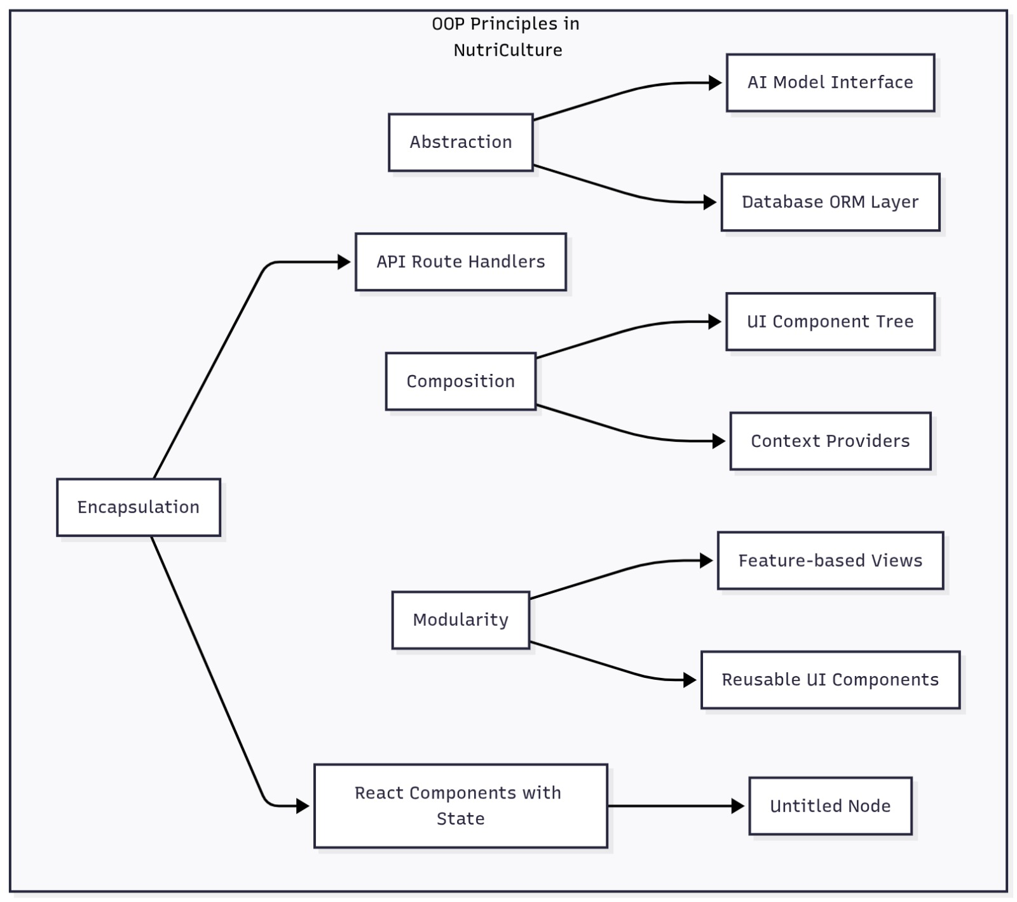
Figure 2 OOP Principles in Nutriculture

4.1 System Architecture
The NutriCulture platform follows a modern N-tier web architecture, specifically designed to handle the decoupling of the user interface, business logic, and the heavy computational requirements of AI processing.
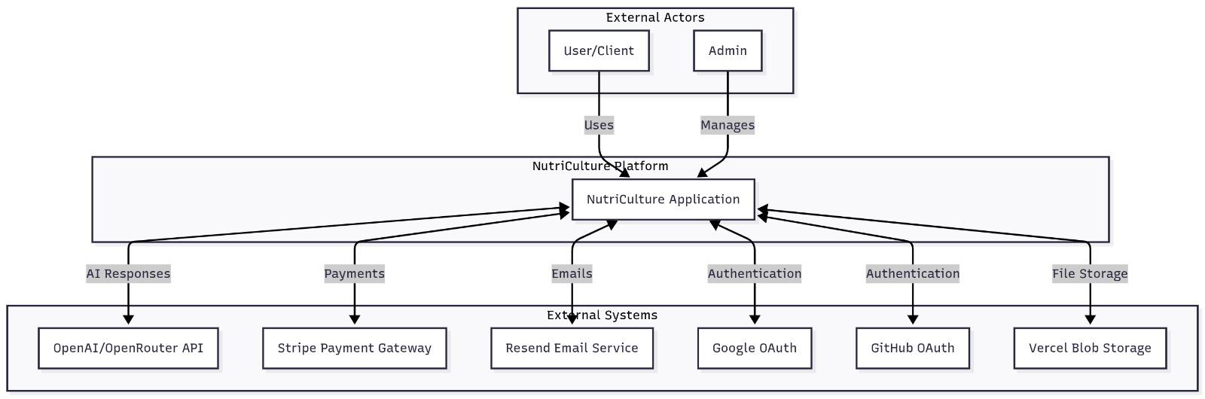
Figure 3 Architecture Diagram

4.1.1 The Full-Stack Framework
The system is built on the Next.js framework, which provides a unified environment for both frontend and backend development.
· Frontend Layer: Developed using Next.js and TypeScript, the frontend focuses on delivering a responsive, type-safe user experience. Tailwind CSS is employed to ensure that the interface remains visually consistent across various device screen sizes.
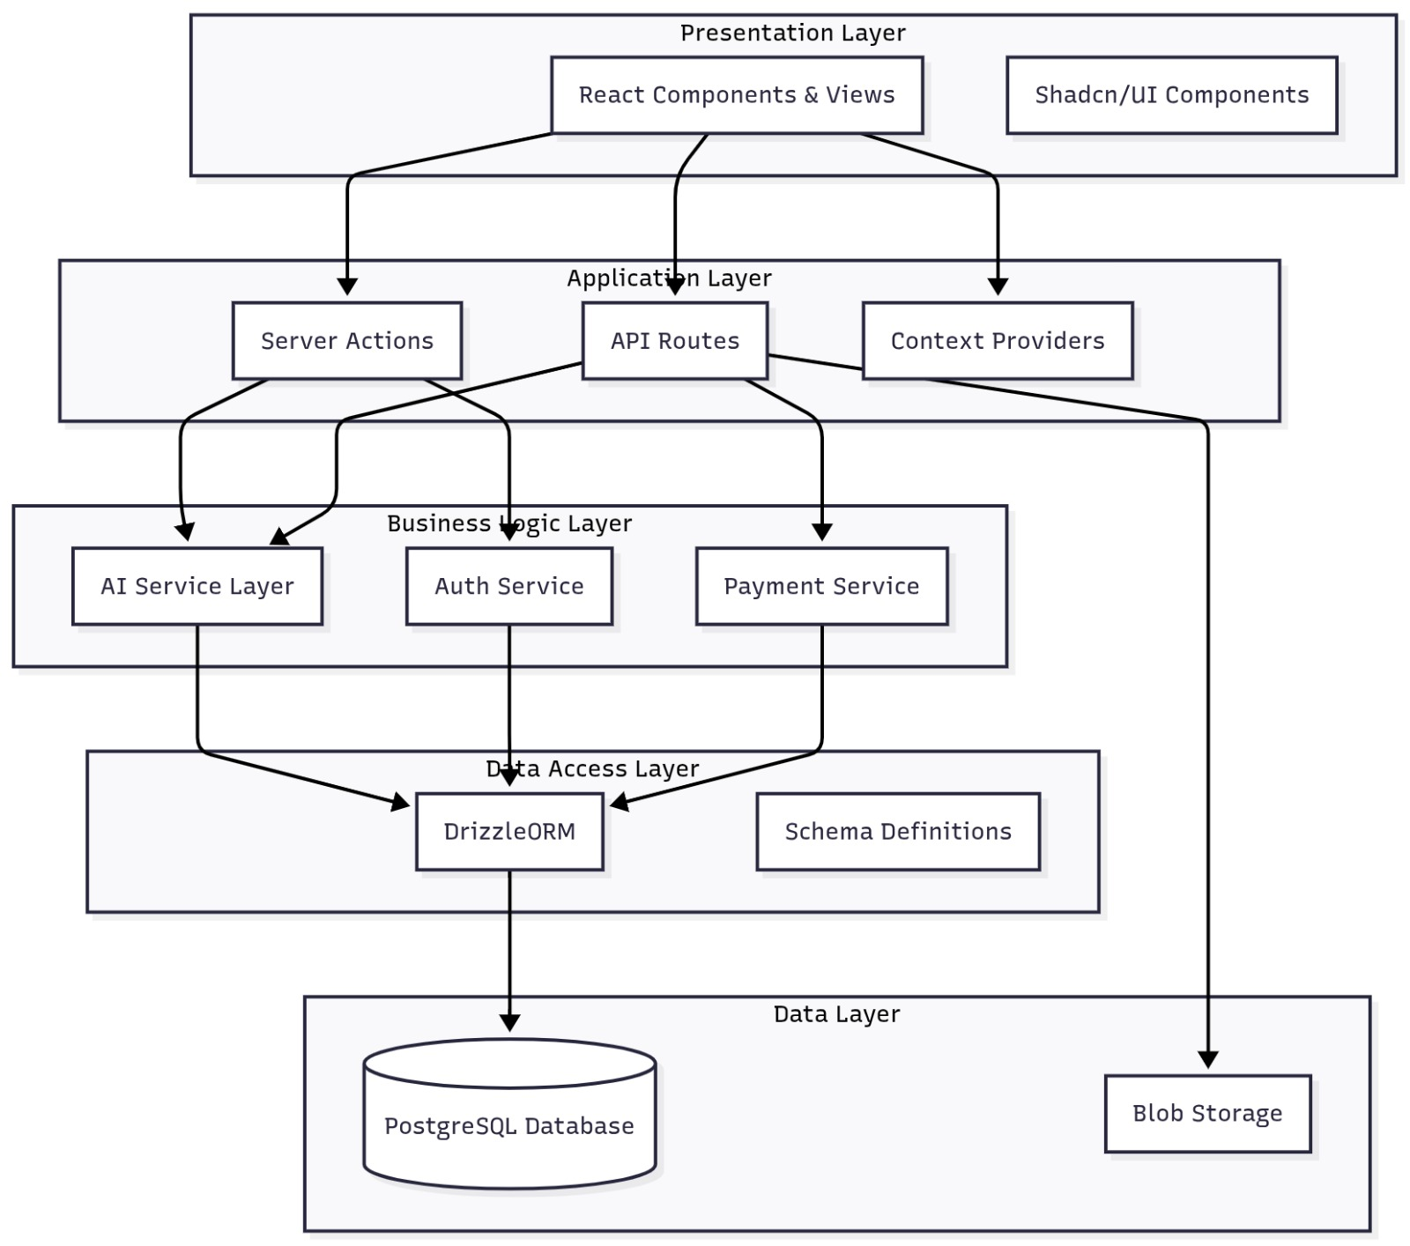
Figure 4 Frontend Structure

· Backend Layer: The backend runs in a Node.js environment, utilizing Express.js principles to manage RESTful API routes. This layer acts as the orchestrator, handling requests from the client, communicating with the database, and managing external AI API calls.
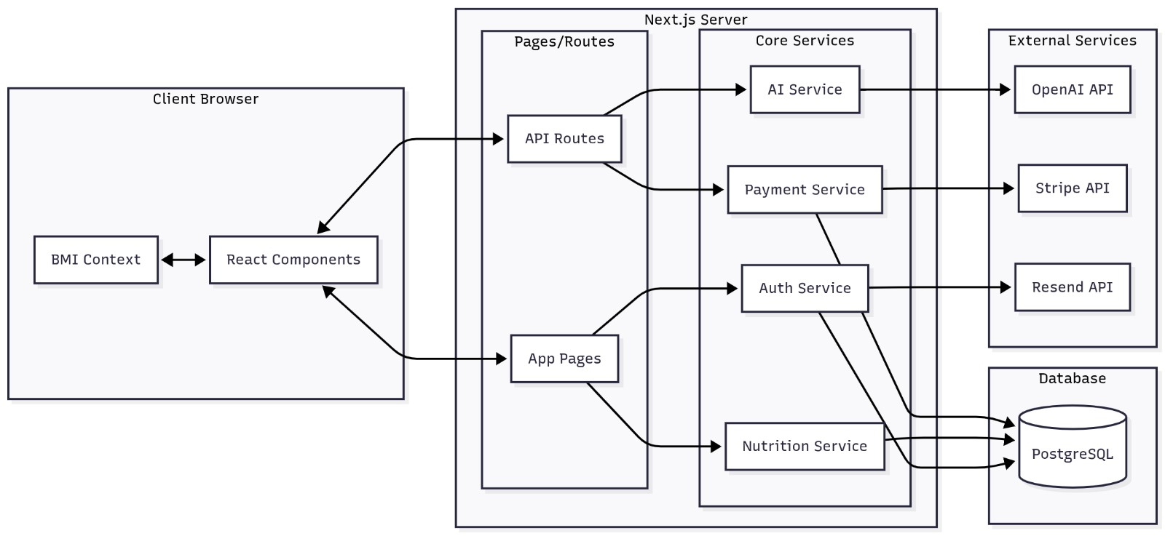
Figure 5 Backend Structure

4.1.2 AI Service Integration Layer
Unlike traditional applications that run all logic locally, NutriCulture utilizes an AI-as-a-Service (AIaaS) model.

· The system consumes pretrained AI APIs for complex tasks such as image recognition and natural language processing.

· All communication between the NutriCulture backend and external AI services (like Google Cloud Vision or GPT-4) occurs over secure HTTPS protocols to ensure user data privacy.
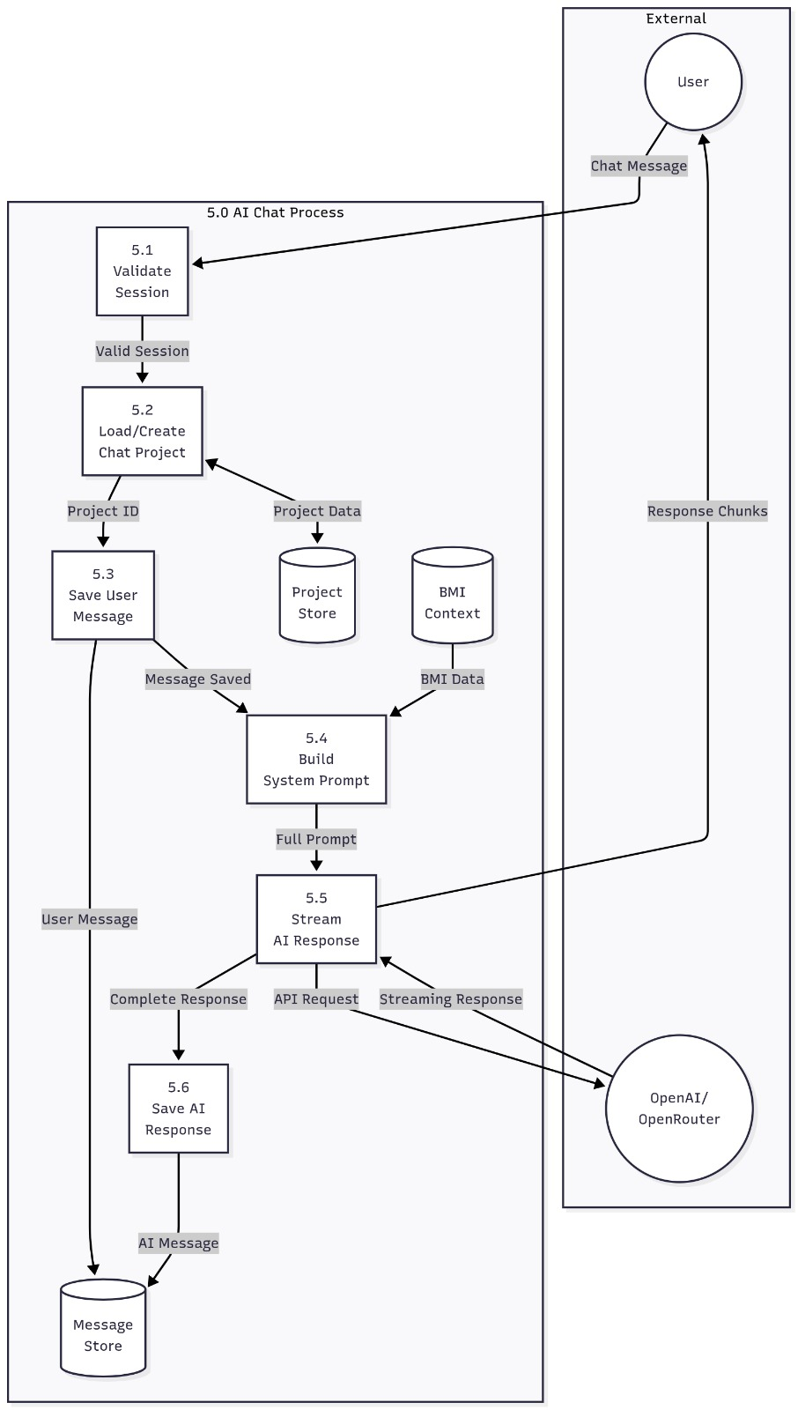
Figure 6 AI Workflow Diagram

4.2 Data Representation
The data layer is the backbone of NutriCulture, requiring a robust structure to store diverse information ranging from user health metrics to complex ingredient lists.

4.2.1 Relational Database Model
The platform utilizes MySQL as its primary relational database management system (RDBMS). To manage this database efficiently, Prisma ORM is used to provide a type-safe interface between the Node.js code and the SQL tables.
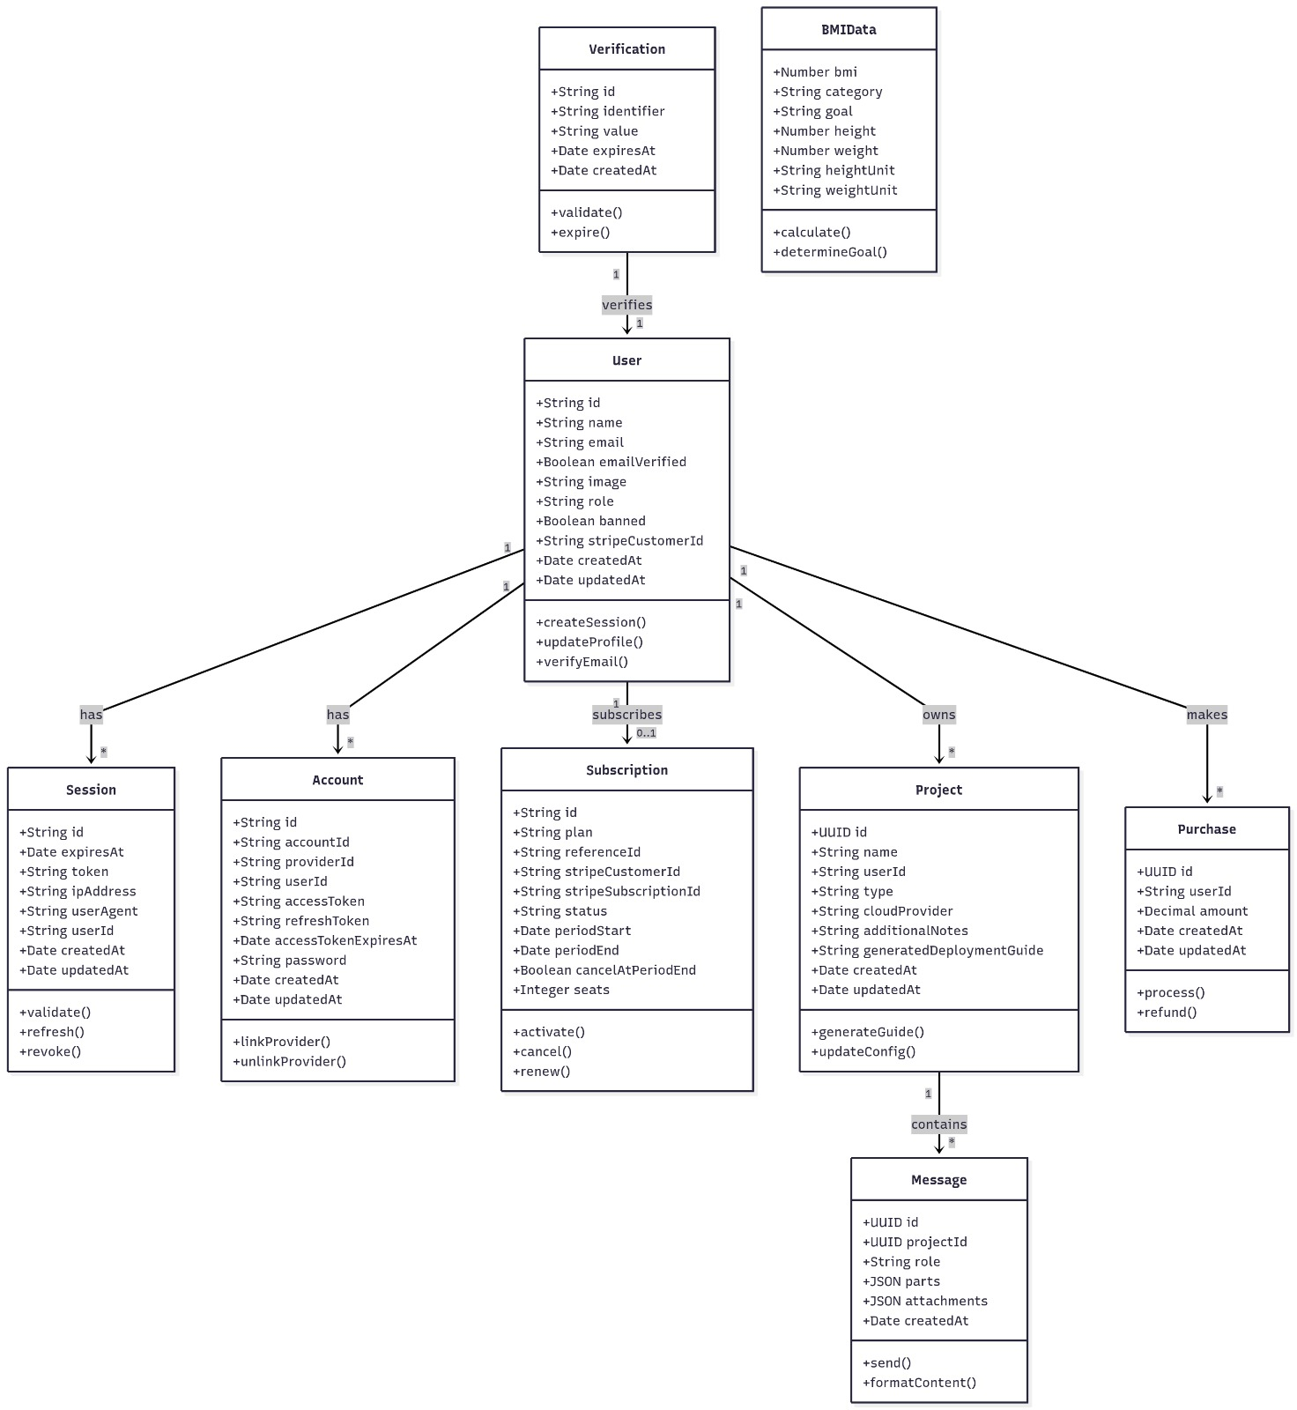
Figure 7 Relational Database Diagram

4.2.2 Key Entities and Attributes
The data is represented through several core entities, each modeled as objects within the system:
· User Table: Stores registration details, secure hashed passwords, and session tokens.

· Profile Table: Contains specific health data including BMI, allergies, and preferred cuisines (South Asian or Middle Eastern).

· Recipe Table: A curated library of traditional dishes, including ingredient lists, preparation steps, and nutritional facts.
· Meal Plan Table: Stores the weekly schedules generated by users or suggested by the AI.
· Analysis Log: Keeps a record of every food image uploaded and the corresponding nutritional breakdown returned by the AI.

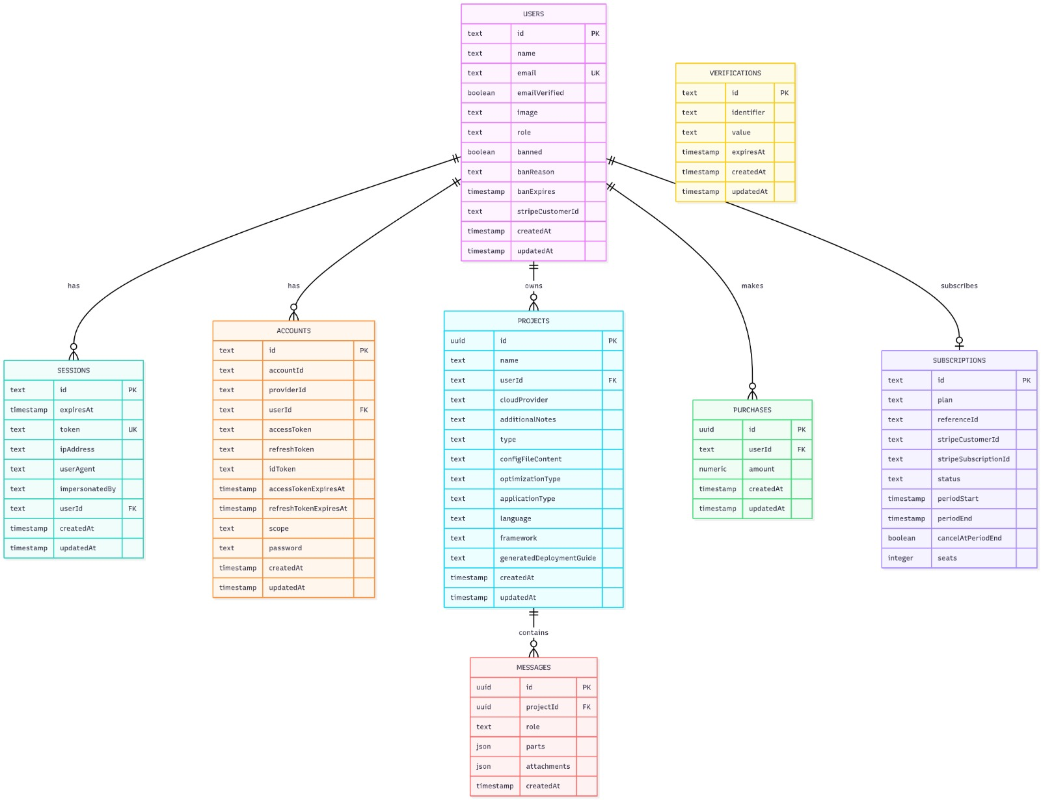
Figure 8 Entity Relationship Diagram ERD

4.3 Process Flow and Representation
The process flow defines the lifecycle of data as it moves through the system. The most complex flow in NutriCulture is the Image-Based Nutrition Analysis.
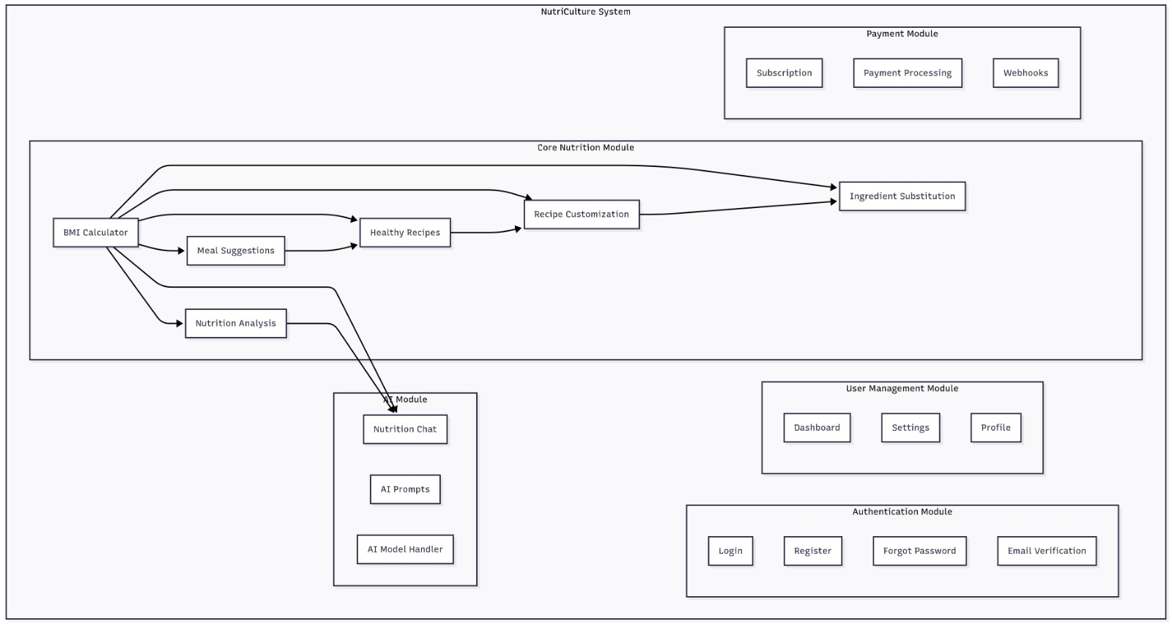
Figure 9 Process Flow Diagram

4.3.1 The Nutrition Analysis Lifecycle
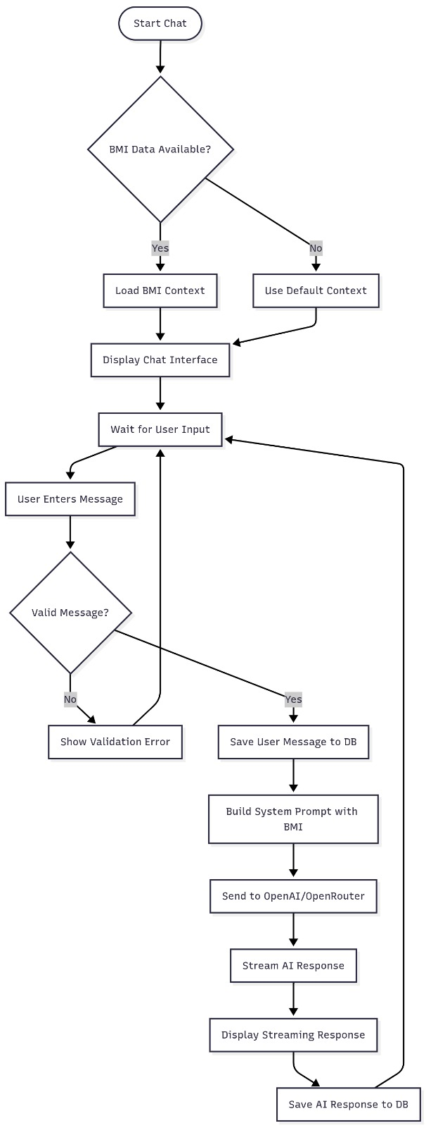
1. Input Acquisition: The user captures or selects an image (up to 5 MB) of a dish via the web interface.
Figure 10 Nutrition Lifecycle Flowchart
2. Secure Transmission: The frontend sends the image to the backend via an asynchronous POST request.
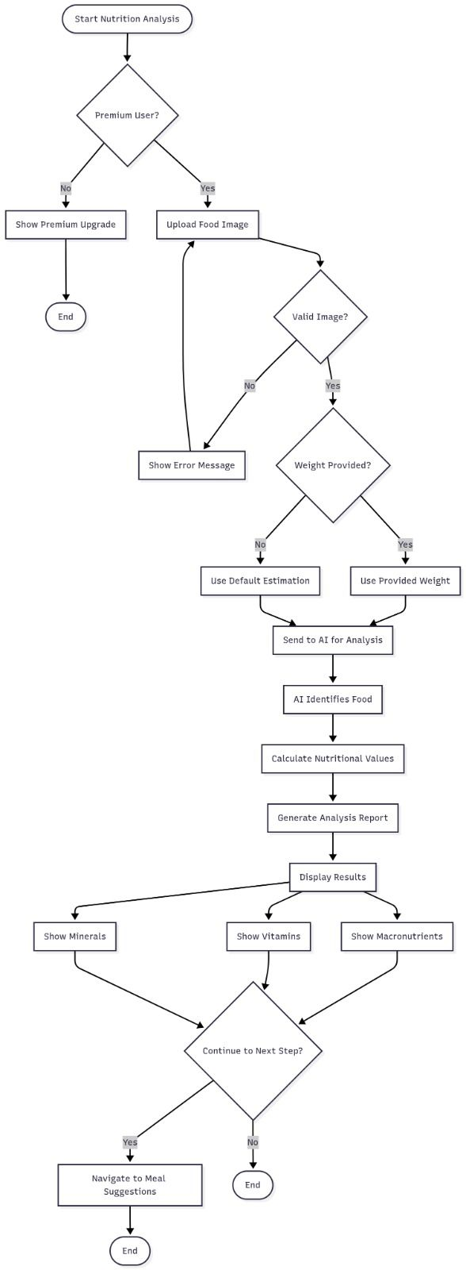
Figure 11 Nutrition Analysis Flowchart

3. API Orchestration: The backend forwards the image to the pretrained AI recognition API.
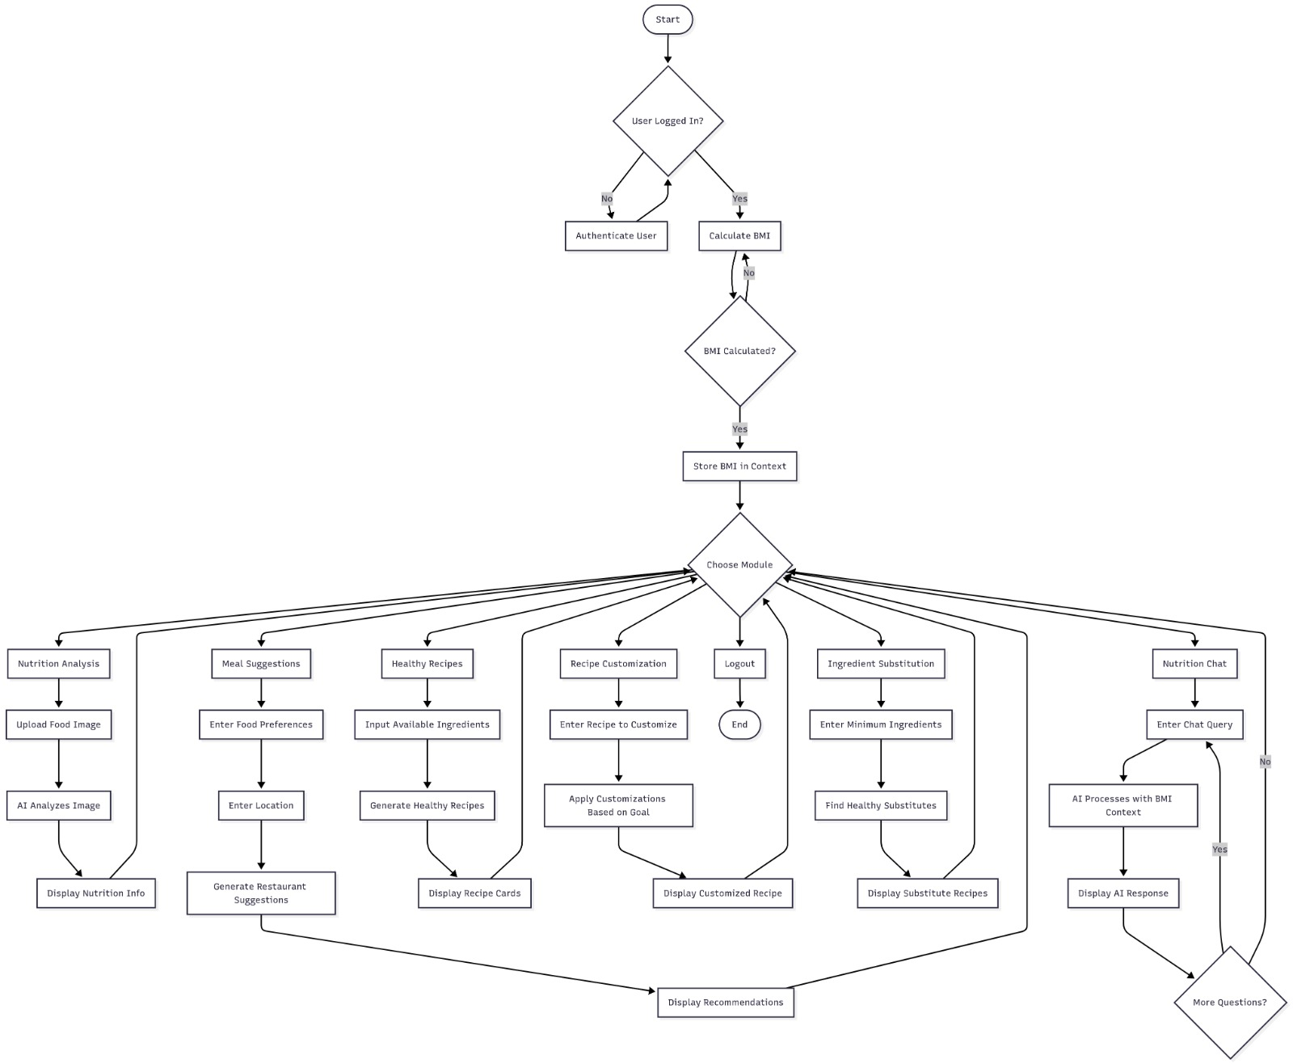
Figure 12 API Orchestration Flowchart

4. Data Parsing: The AI returns a JSON object containing the detected dish name and its estimated nutritional profile.
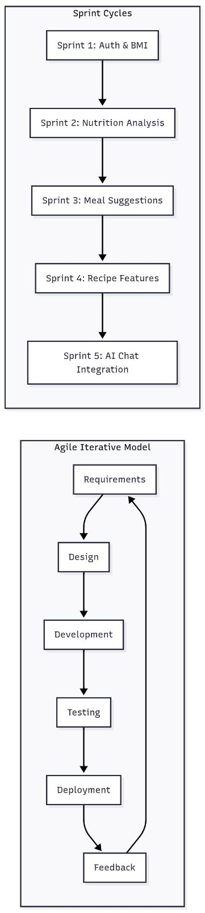
Figure 13 System Development Lifecycle
- Output Visualization: The system displays the calories, protein, fats, and carbs to the user and logs the entry for historical tracking.
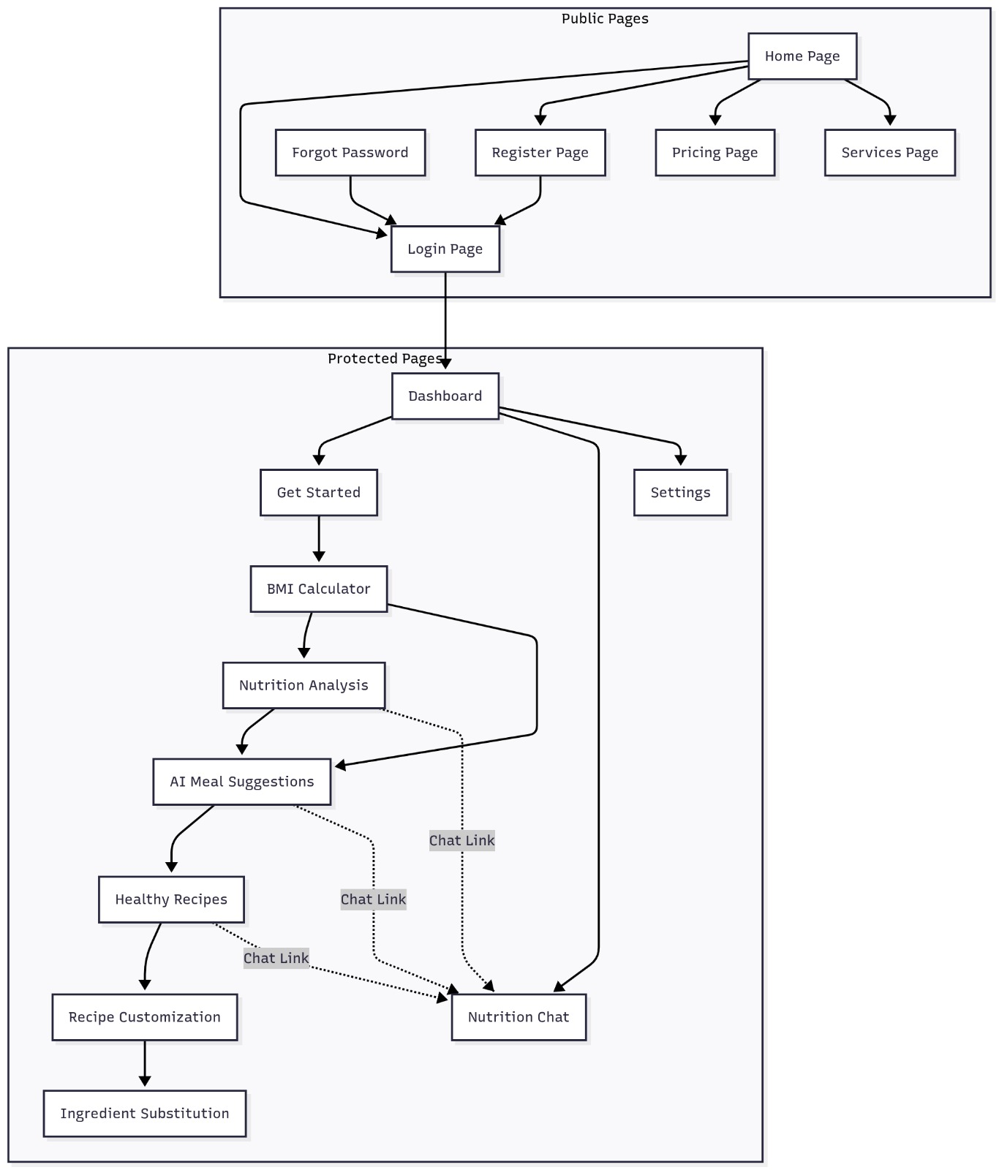
Figure 14 Frontend Workflow diagram

4.4 Design Models
To ensure the system is maintainable and scalable, several design models were developed during the architecture phase.

4.4.1 Modularity through OOM
The system is divided into eight distinct modules, each with isolated logic:
· Module 1 & 2: Handle the user's identity and the core recipe database.

· Module 3 & 5: Manage the scheduling and recommendation logic for personalized nutrition.

· Module 4: Dedicated to the CNN-based image classification tasks.

· Module 6 & 7: Provide the intelligent substitution and customization features.

4.5 Activity Diagram
The Activity Diagram is as follows:
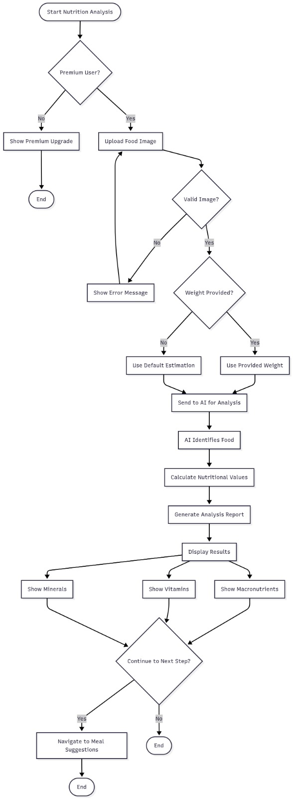
Figure 15 Activity Diagram

4.5 Sequence Diagrams.
The Sequence Diagrams of the Nutriculture app are as follows :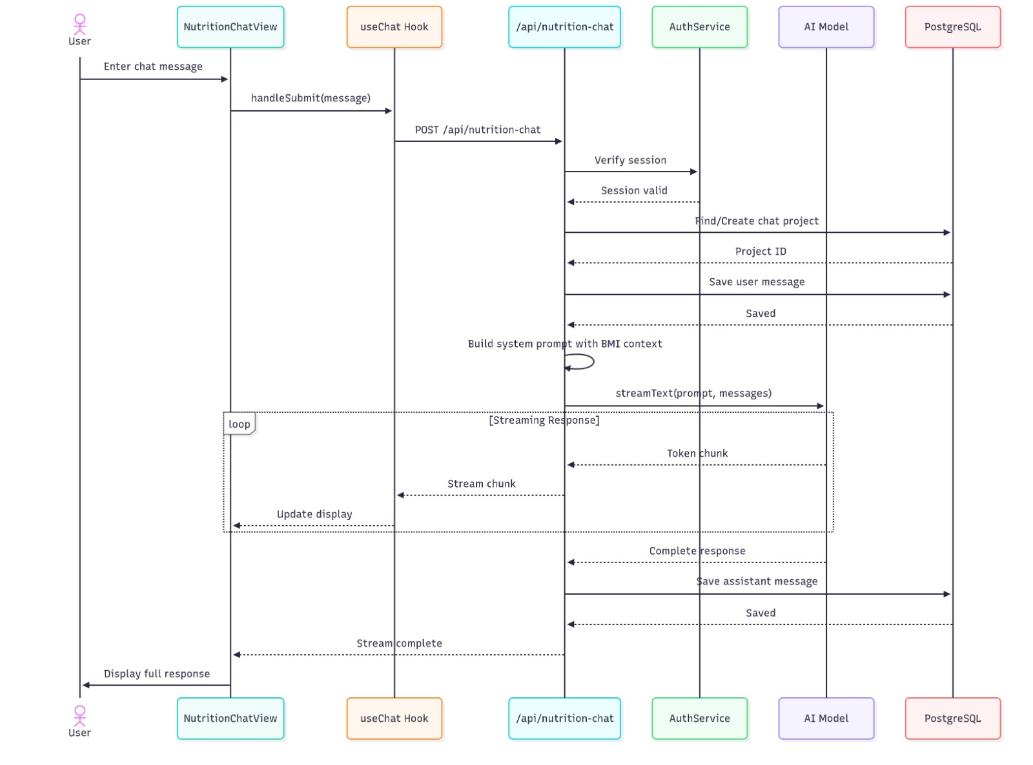
Figure 16 Sequence Diagram

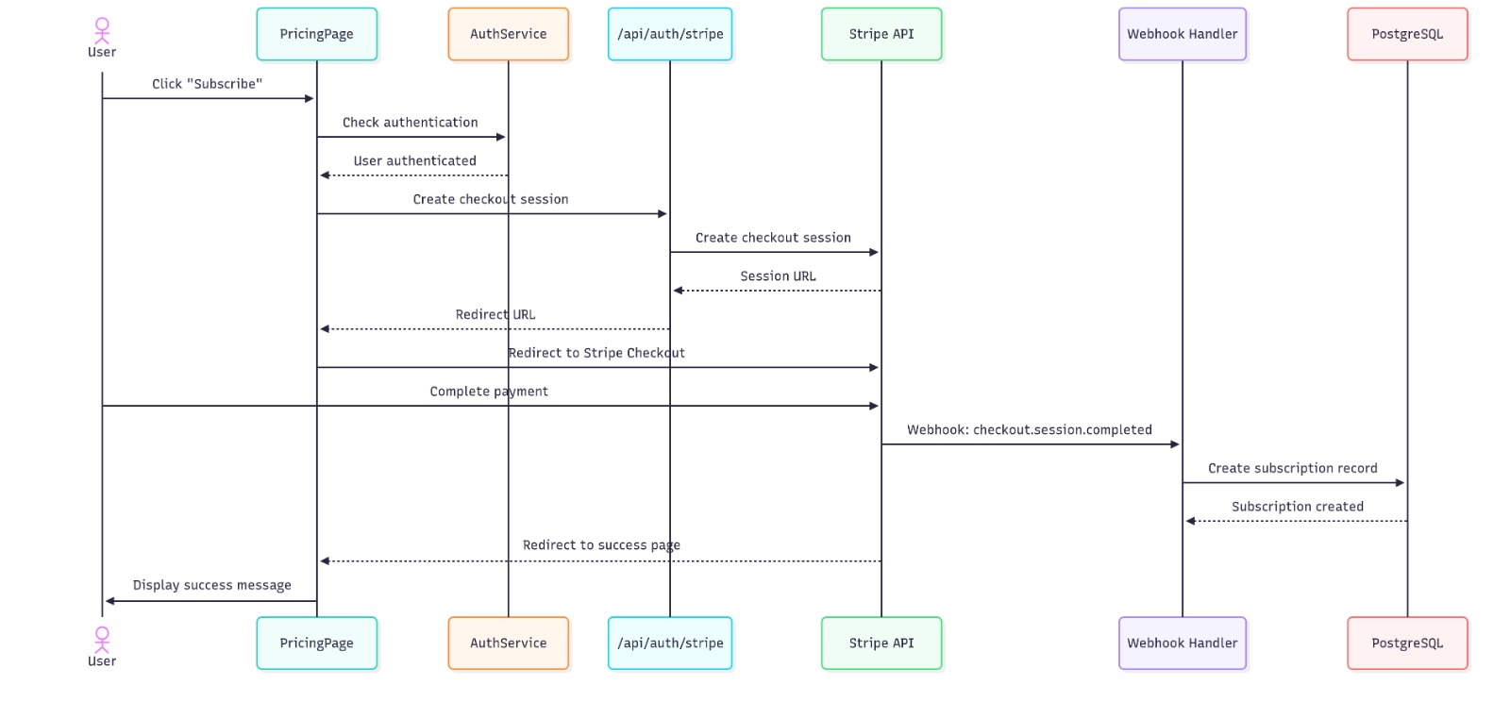
Figure 17 Data flow Diagram

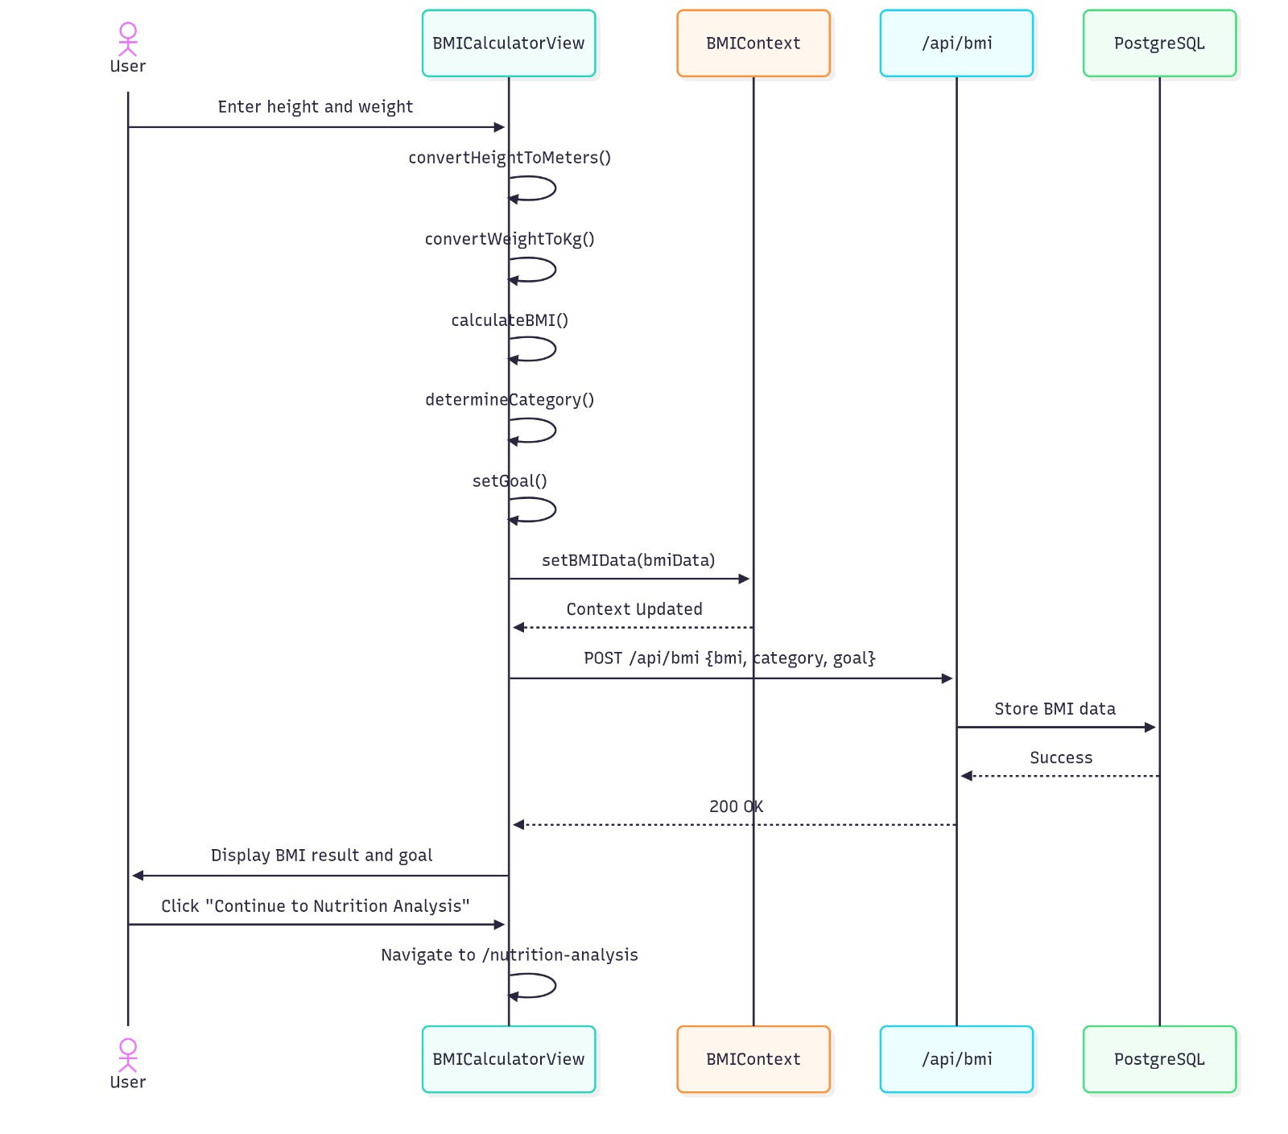
Figure 18 Process Data visual Diagram .

Chapter 5
IMPLEMENTATION

The implementation phase is where the architectural designs are converted into a functional software product. This chapter details the specific algorithms used for health calculations and AI processing, the integration of third-party APIs, and the development of the user interface. NutriCulture is implemented as a full-stack Next.js application, utilizing TypeScript for robust type checking and Prisma ORM for seamless database communication.

5.1 Algorithm Development
The "intelligence" of NutriCulture is derived from a combination of mathematical formulas and AI-driven logic. Several key algorithms were implemented to handle the core functionality of the platform.

5.1.1 Body Mass Index (BMI) and Goal Mapping Algorithm
The BMI calculator serves as the entry point for personalized nutrition. The implementation follows the standard metric formula:
Once the BMI is calculated, the system executes a mapping algorithm to categorize the user and suggest an initial calorie target:
1. Underweight (< 18.5): Suggests a high-protein, calorie-surplus plan.
2. Normal (18.5 – 24.9): Suggests a maintenance plan focusing on nutrient density.
3. Overweight (25.0 – 29.9): Suggests a moderate calorie deficit (e.g., -500 kcal/day).
4. Obese (≥ 30.0): Suggests a structured weight-management plan with an emphasis on low-glycemic traditional foods.

5.1.2 Image-to-Nutrition Inference Logic
The logic for processing food images involves a multi-step inference pipeline:
· Step 1: Image Pre-processing: The uploaded image is resized and normalized on the client side to reduce bandwidth usage before being sent to the server.
· Step 2: API Invocation: The backend sends the image buffer to a pretrained Convolutional Neural Network (CNN) via an external API.
· Step 3: Confidence Thresholding: The system receives a list of detected items. A threshold (e.g., 85% confidence) is applied to ensure accuracy. If multiple items are detected, the system prioritizes those found in the regional cuisine database.
· Step 4: Nutritional Retrieval: The dish name is cross-referenced with a nutritional database to fetch calories, fats, proteins, and carbohydrates.

5.1.3 Recommendation Engine (Content-Based Filtering)
The AI Meal Recommender uses a content-based filtering approach. It analyzes the "metadata" of recipes—such as ingredients, cuisine type, and caloric value—and matches them against the user's profile (allergies, preferences, and BMI goals).

5.2 External APIs and Integration
A defining characteristic of NutriCulture is its use of the AI-as-a-Service (AIaaS) model. By integrating industry-standard APIs, the system achieves professional-grade accuracy without the overhead of maintaining local models.

5.2.1 Nutritionix API
The Nutritionix API is the primary source for nutritional data. It is used to:
· Retrieve detailed micronutrient and macronutrient profiles for thousands of ingredients.
· Provide natural language processing (NLP) capabilities to parse "User-Customized" recipes where quantities are manually changed.

5.2.2 Google Cloud Vision / Food-101 Based APIs
For the Nutrition Analyzer, the system integrates with specialized food recognition services. These APIs are trained on massive datasets like Food-101, which include a diverse range of international dishes. This ensures that a photo of Chicken Tikka or Falafel is recognized with high precision.

5.2.3 OpenAI GPT-4 API
The Ingredient Substitute Generator and the AI Chatbot are powered by the OpenAI API.
· Substitution Logic: The system sends a prompt containing the original recipe and the user's restriction (e.g., "Make this Biryani lower in fat"). The AI returns specific substitutions, such as replacing Ghee with olive oil or full-fat yogurt with a low-fat alternative.
· Reasoning: Unlike a simple database lookup, the LLM provides the rationale for the swap, helping to educate the user.

5.3 User Interface Implementation
The UI is designed to be clean, responsive, and culturally intuitive. It is implemented using Tailwind CSS for styling and Lucide-React for iconography.

5.3.1 The Dashboard
The dashboard acts as a central hub, providing a "snapshot" of the user's health.
· Visual Progress Bars: Real-time visualization of daily calorie consumption vs. goals.
· Quick Action Buttons: Direct links to the Nutrition Analyzer and the Meal Planner.

5.3.2 Recipe Explorer and Filters
The Recipe Explorer is implemented as a dynamic grid. It features:
· Asynchronous Search: Users can search for dishes in real-time without page refreshes.
· Cultural Filters: Specialized tags for "Pakistani," "Indian," "Arabian," and "Turkish" cuisines.
· Detail Modals: Clicking a recipe opens a detailed view showing the preparation steps and a "Customize This" button, which triggers the AI logic for healthier variations.

5.3.3 The Meal Planner Interface
The planner uses a drag-and-drop paradigm (or a simple selection grid on mobile). It is built to handle:
· Weekly Views: Allowing users to plan from Monday to Sunday.
· Automatic Summaries: The system calculates the total weekly nutritional load as the user adds or removes meals.

5.4 Backend Logic and Security Implementation
The backend of NutriCulture is developed using Node.js and Express.js, acting as the central nervous system that coordinates between the frontend, the database, and external AI services. The implementation focuses on three pillars: performance, scalability, and robust security.

5.4.1 Security and Authentication (JWT)
Security is paramount as the platform handles sensitive health and dietary information.
· Token-Based Authentication: The system utilizes JSON Web Tokens (JWT) for session management. Upon a successful login, the server generates a signed token containing the user's ID and role, which is stored in a secure, HTTP-only cookie on the client side.

· Password Hashing: To prevent credential theft, raw passwords are never stored. We implemented Bcrypt hashing with a salt factor of 12, ensuring that even if the database is compromised, user passwords remain encrypted.

· Protected Routes: Middleware functions intercept every request to sensitive modules (like the Meal Planner or Nutrition Analyzer) to verify the JWT's signature before allowing data access.

5.4.2 Request Handling and Middleware
The backend uses a series of custom middleware to ensure data integrity:
· Input Validation: Using libraries like Zod or Joi, every incoming request (especially recipe customizations) is validated against a schema to prevent SQL injection or malformed data from reaching the database.
· CORS Management: Cross-Origin Resource Sharing is strictly configured to only allow requests from the official NutriCulture frontend domain, protecting the API from unauthorized external calls.

5.5 Database Management and Schema Design
The data persistence layer is built on Postgresql , a relational database chosen for its ability to handle the complex relationships between users, recipes, and daily nutritional logs.

Figure 19 Database Schema

5.5.1 Neon ORM Integration
To bridge the gap between our TypeScript code and the SQL database, we implemented Prisma ORM.

· Type Safety: Prisma auto-generates a client based on our database schema, ensuring that every database query is checked for errors at compile-time.

· Schema Migrations: The "Prisma Migrate" tool is used to manage changes to the database structure, allowing the team to add new features (like allergy tracking) without manually writing complex SQL ALTER statements.

5.5.2 Data Modeling and Relationships
The schema is designed for high efficiency:
· One-to-One: A User is linked to a single Profile containing their BMI and health goals.

· One-to-Many: A User can have multiple MealPlan entries and AnalysisLog records (for food image uploads).

· Many-to-Many: Recipes and Ingredients are linked via a junction table, allowing the system to quickly calculate the total nutritional value of a dish by summing its constituent parts.
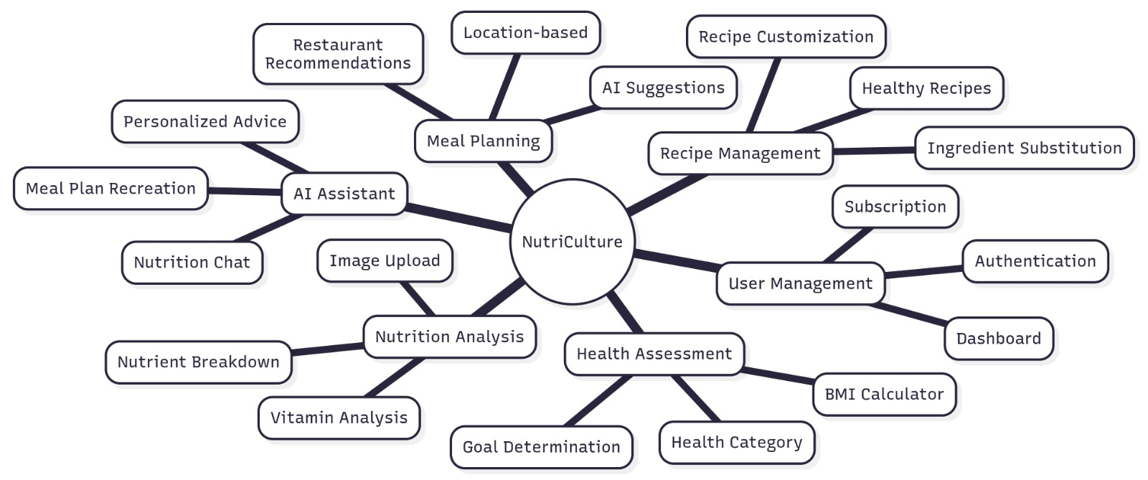
Figure 20 Data Modeling

5.6 API Orchestration and Data Interchange
NutriCulture relies heavily on communication between internal and external software interfaces. This orchestration ensures that a user's food photo is correctly identified and translated into actionable health data.

5.6.1 Standardizing with Axios and JSON
All communication within the system uses JSON (JavaScript Object Notation) as the standard data interchange format.
· Axios Client: The frontend utilizes the Axios library to manage asynchronous HTTP requests to the backend. It is configured with interceptors to automatically include the user's authentication token in every header.

· RESTful Design: The API follows REST principles, using standard HTTP methods—GET for retrieving recipes, POST for uploading images, and PUT for updating meal plans.

5.6.2 External API Lifecycle and Error Handling
Communication with external AI services (like Google Cloud Vision or OpenAI) is handled via secure server-to-server calls.

· Async/Await Logic: Since AI analysis can take several seconds, the backend uses async/await patterns to ensure the main thread is not blocked, allowing the application to remain responsive.
· Fallback Mechanisms: If an external API (like the Nutritionix database) is temporarily unavailable, the system is designed to trigger "fallback" messages or use cached data to ensure the user can still access basic features.

· API Key Masking: All sensitive API keys are stored in environment variables (.env) and are never exposed to the client-side code, ensuring that our AI service quotas cannot be hijacked.


Figure 21 External API Lifecycle and Error Handling

Chapter 6
TESTING AND EVALUATION

Testing is a critical phase in the Software Development Life Cycle (SDLC) for the AI-Enhanced NutriCulture platform. It ensures that the system meets all functional and non-functional requirements, integrates external AI APIs correctly, and provides a secure, seamless user experience. This chapter details the comprehensive testing strategy, covering Manual, System, Unit, Functional, Integration, and Automated testing.

6.1 Manual Testing
Manual testing involves human testers navigating the NutriCulture platform to identify UI/UX inconsistencies, exploratory edge cases, and layout issues across different devices.

6.1.1 TEST CASES FOR UI NAVIGATION
This test case ensures that the main navigation menu routes users correctly without dead links.
Table 1: TEST CASES FOR UI NAVIGATION
· TEST CASE ID: TC-M01 | Author: Muhammad Ali | Priority: High
· Dated: 2026-04-10 | Test Case Name: Navigation Bar Routing | Executed By: Samran Sohail
· Description: Tests all primary header links from the dashboard.
· Pre-Condition: User is logged in and on the Dashboard.
Table 22 TEST CASES FOR UI NAVIGATION
Step No. | Test Step Details | Test Data | Expected Result | Actual Result | Status | Popup
1 | Click "Recipe Explorer" | None | Redirects to /recipes | Redirected to /recipes | Passed | None
2 | Click "Meal Planner" | None | Redirects to /planner | Redirected to /planner | Passed | None

6.1.2 TEST CASES FOR RESPONSIVE DESIGN (MOBILE)
This test case ensures the platform scales down correctly for mobile screens.
Table 2: TEST CASES FOR RESPONSIVE DESIGN
· TEST CASE ID: TC-M02 | Author: Umer Saleem | Priority: High
· Dated: 2026-04-10 | Test Case Name: Mobile Viewport Check | Executed By: Muhammad Ali
· Description: Tests UI rendering on a standard mobile viewport size.
· Pre-Condition: Application is running in a browser.
Table 23 TEST CASES FOR RESPONSIVE DESIGN
Step No. | Test Step Details | Test Data | Expected Result | Actual Result | Status | Popup
1 | Resize browser to 375x812 | Window size | Elements stack vertically | Elements stacked properly | Passed | None
2 | Open hamburger menu | Click event | Sidebar menu slides in | Sidebar menu slides in | Passed | None

6.1.3 TEST CASES FOR FORM ACCESSIBILITY
Ensures screen readers can parse form inputs.
Table 3: TEST CASES FOR FORM ACCESSIBILITY
· TEST CASE ID: TC-M03 | Author: Samran Sohail | Priority: Medium
· Dated: 2026-04-11 | Test Case Name: Aria-Label Check | Executed By: Umer Saleem
· Description: Checks if ARIA labels are present on login form.
· Pre-Condition: User is on the login page.
Table 24 TEST CASES FOR FORM ACCESSIBILITY
Step No. | Test Step Details | Test Data | Expected Result | Actual Result | Status | Popup
1 | Inspect Email Field | DOM element | aria-label="Email Address" | aria-label is present | Passed | None
2 | Use Tab key to navigate | Keypress | Focus moves sequentially | Focus moved correctly | Passed | None

6.1.4 TEST CASES FOR MANUAL IMAGE UPLOAD
Tests the UI behavior when a user manually drags and drops a food image.
Table 4: TEST CASES FOR MANUAL IMAGE UPLOAD
· TEST CASE ID: TC-M04 | Author: Muhammad Ali | Priority: High
· Dated: 2026-04-12 | Test Case Name: Drag and Drop Upload | Executed By: Samran Sohail
· Description: Verifies the dropzone UI reacts to file hovering.
· Pre-Condition: User is on the Nutrition Analyzer page.
Table 25 TEST CASES FOR MANUAL IMAGE UPLOAD
Step No. | Test Step Details | Test Data | Expected Result | Actual Result | Status | Popup
1 | Drag image over dropzone | biryani.jpg | Box highlights green | Box highlighted green | Passed | None
2 | Drop image | biryani.jpg | Thumbnail appears | Thumbnail rendered | Passed | None

6.1.5 TEST CASES FOR ERROR STATE UI
Tests how the UI handles API timeouts manually.
Table 5: TEST CASES FOR ERROR STATE UI
· TEST CASE ID: TC-M05 | Author: Umer Saleem | Priority: Medium
· Dated: 2026-04-12 | Test Case Name: Offline Error State | Executed By: Muhammad Ali
· Description: Verifies toaster notifications appear on network drop.
· Pre-Condition: User turns off network connection via dev tools.
Table 26 TEST CASES FOR ERROR STATE UI
Step No. | Test Step Details | Test Data | Expected Result | Actual Result | Status | Popup
1 | Click "Search Recipes" | "Chicken" | UI shows loading state | Loading spinner shown | Passed | None
2 | Wait 5 seconds | None | Error toaster shows "Network Error" | Error toaster rendered | Passed | Yes

6.1.6 TEST CASES FOR COLOR CONTRAST
Ensures text is readable against backgrounds.
Table 6: TEST CASES FOR COLOR CONTRAST
· TEST CASE ID: TC-M06 | Author: Samran Sohail | Priority: Low
· Dated: 2026-04-13 | Test Case Name: Dashboard Contrast | Executed By: Umer Saleem
· Description: Manual check of text contrast ratios.
· Pre-Condition: User is logged into the dashboard.
Table 27 TEST CASES FOR COLOR CONTRAST
Step No. | Test Step Details | Test Data | Expected Result | Actual Result | Status | Popup
1 | View calorie counter text | Visual | Text is clearly legible | Text was highly legible | Passed | None
2 | Run Lighthouse contrast tool | Tool input | Score 100/100 | Score 100/100 | Passed | None

6.1.7 TEST CASES FOR MEAL PLANNER DRAG-AND-DROP
Tests the manual interaction of building a meal plan.
Table 7: TEST CASES FOR MEAL PLANNER DRAG-AND-DROP
· TEST CASE ID: TC-M07 | Author: Muhammad Ali | Priority: High
· Dated: 2026-04-14 | Test Case Name: Drag Recipe to Day | Executed By: Samran Sohail
· Description: Ensures recipes snap to the correct day column.
· Pre-Condition: User is on the Meal Planner page.
Table 28 TEST CASES FOR MEAL PLANNER DRAG-AND-DROP
Step No. | Test Step Details | Test Data | Expected Result | Actual Result | Status | Popup
1 | Click and hold Recipe Card | Card ID: 12 | Card follows cursor | Card followed cursor | Passed | None
2 | Release over "Monday" slot | MouseUp | Card snaps into Monday | Card snapped correctly | Passed | None

6.1.8 TEST CASES FOR LOGOUT BEHAVIOR
Ensures session clears completely on manual logout.
Table 8: TEST CASES FOR LOGOUT BEHAVIOR
· TEST CASE ID: TC-M08 | Author: Umer Saleem | Priority: High
· Dated: 2026-04-14 | Test Case Name: Manual Session Clear | Executed By: Muhammad Ali
· Description: Tests if user can access protected routes after logout.
· Pre-Condition: User is logged in.
Table 29 TEST CASES FOR LOGOUT BEHAVIOR
Step No. | Test Step Details | Test Data | Expected Result | Actual Result | Status | Popup
1 | Click "Logout" | None | Redirected to Home | Redirected to Home | Passed | None
2 | Click browser "Back" button | None | Redirected back to Login | Redirected to Login | Passed | None

6.1.9 TEST CASES FOR DARK MODE TOGGLE
Tests the theme switching feature.
Table 9: TEST CASES FOR DARK MODE TOGGLE
· TEST CASE ID: TC-M09 | Author: Samran Sohail | Priority: Medium
· Dated: 2026-04-15 | Test Case Name: Theme Switcher | Executed By: Umer Saleem
· Description: Verifies CSS classes change on toggle click.
· Pre-Condition: User is on any page.
Table 30 TEST CASES FOR DARK MODE TOGGLE
Step No. | Test Step Details | Test Data | Expected Result | Actual Result | Status | Popup
1 | Click Moon icon | Click event | Background turns dark | Background turned dark | Passed | None
2 | Refresh page | F5 | Theme remains dark | Theme persisted | Passed | None

6.1.10 TEST CASES FOR RECIPE MODAL CLOSE
Tests UI modal interactions.
Table 10: TEST CASES FOR RECIPE MODAL CLOSE
· TEST CASE ID: TC-M10 | Author: Muhammad Ali | Priority: Low
· Dated: 2026-04-15 | Test Case Name: Escape Key Modal Close | Executed By: Samran Sohail
· Description: Ensures modals can be closed via keyboard.
· Pre-Condition: A recipe detail modal is open.
Table 31 TEST CASES FOR RECIPE MODAL CLOSE
Step No. | Test Step Details | Test Data | Expected Result | Actual Result | Status | Popup
1 | Press ESC key | KeyCode 27 | Modal closes | Modal closed | Passed | None
2 | Click outside modal window | Click event | Modal closes | Modal closed | Passed | None

6.2 System Testing
System testing evaluates the complete, integrated application against the specified requirements to check overall performance, security, and end-to-end flows.

6.2.1 TEST CASES FOR END-TO-END REGISTRATION TO PLANNER
Validates a complete new user journey.
Table 11: TEST CASES FOR E2E USER JOURNEY
· TEST CASE ID: TC-S01 | Author: Umer Saleem | Priority: High
· Dated: 2026-04-16 | Test Case Name: Full User Flow | Executed By: Muhammad Ali
· Description: Tests registration, profile creation, and meal plan generation sequentially.
· Pre-Condition: Database is running; system is online.

Table 32 TEST CASES FOR E2E USER JOURNEY
Step No. | Test Step Details | Test Data | Expected Result | Actual Result | Status | Popup
1 | Register new account & fill profile | user@test.com, BMI 26 | Account created | Account created | Passed | None
2 | Click "Generate Meal Plan" | AI Request | Full weekly plan displayed | Weekly plan displayed | Passed | None

6.2.2 TEST CASES FOR CONCURRENT LOGINS
Tests the system's ability to handle multiple sessions.
Table 12: TEST CASES FOR CONCURRENT LOGINS
· TEST CASE ID: TC-S02 | Author: Samran Sohail | Priority: High
· Dated: 2026-04-16 | Test Case Name: Multi-Device Access | Executed By: Umer Saleem
· Description: Logs into the same account from two different browsers.
· Pre-Condition: Valid user account exists.
Table 33 TEST CASES FOR CONCURRENT LOGINS
Step No. | Test Step Details | Test Data | Expected Result | Actual Result | Status | Popup
1 | Login on Chrome | user@test.com | Success | Session active | Passed | None
2 | Login on Firefox with same creds | user@test.com | Success | Both sessions active | Passed | None

6.2.3 TEST CASES FOR LARGE FILE UPLOADS
Tests system stability under heavy payload stress.
Table 13: TEST CASES FOR LARGE FILE UPLOADS
· TEST CASE ID: TC-S03 | Author: Muhammad Ali | Priority: Medium
· Dated: 2026-04-17 | Test Case Name: 10MB Image Rejection | Executed By: Samran Sohail
· Description: Ensures system rejects files over the 5MB limit gracefully.
· Pre-Condition: User is on Nutrition Analyzer.
Table 34 TEST CASES FOR LARGE FILE UPLOADS
Step No. | Test Step Details | Test Data | Expected Result | Actual Result | Status | Popup
1 | Upload 10MB image | huge_food.png | System blocks upload | Upload blocked | Passed | None
2 | Verify error message | None | "File exceeds 5MB limit" | Error displayed | Passed | Yes

6.2.4 TEST CASES FOR API RATE LIMITING
Tests security measures against DDoS or API spam.
Table 14: TEST CASES FOR API RATE LIMITING
· TEST CASE ID: TC-S04 | Author: Umer Saleem | Priority: High
· Dated: 2026-04-17 | Test Case Name: Throttle AI Requests | Executed By: Muhammad Ali
· Description: Fires 20 rapid requests to the AI recommendation endpoint.
· Pre-Condition: User is logged in.
Table 35 TEST CASES FOR API RATE LIMITING
Step No. | Test Step Details | Test Data | Expected Result | Actual Result | Status | Popup
1 | Send 20 requests in 5 seconds | Postman script | Status 429 Too Many Requests | HTTP 429 received | Passed | None
2 | Wait 1 minute, send 1 request | Postman script | Status 200 OK | HTTP 200 OK | Passed | None

6.2.5 TEST CASES FOR CROSS-BROWSER COMPATIBILITY
Ensures system works uniformly across browsers.
Table 15: TEST CASES FOR CROSS-BROWSER COMPATIBILITY
· TEST CASE ID: TC-S05 | Author: Samran Sohail | Priority: High
· Dated: 2026-04-18 | Test Case Name: Safari & Edge Render | Executed By: Umer Saleem
· Description: Loads the heavy Meal Planner UI on different browser engines.
· Pre-Condition: Web app deployed to staging.
Table 36 TEST CASES FOR CROSS-BROWSER COMPATIBILITY
Step No. | Test Step Details | Test Data | Expected Result | Actual Result | Status | Popup
1 | Open Planner in Safari (macOS) | URL | UI renders without overlap | Perfect rendering | Passed | None
2 | Open Planner in MS Edge (Win) | URL | UI renders without overlap | Perfect rendering | Passed | None

6.2.6 TEST CASES FOR DATABASE FAILOVER
Tests system resilience when DB connection drops.
Table 16: TEST CASES FOR DATABASE FAILOVER
· TEST CASE ID: TC-S06 | Author: Muhammad Ali | Priority: High
· Dated: 2026-04-18 | Test Case Name: DB Disconnect Handling | Executed By: Samran Sohail
· Description: Simulates DB crash and checks application response.
· Pre-Condition: User is browsing recipes.
Table 37 TEST CASES FOR DATABASE FAILOVER
Step No. | Test Step Details | Test Data | Expected Result | Actual Result | Status | Popup
1 | Stop MySQL Service | CLI Command | Backend catches error | Error caught by Prisma | Passed | None
2 | Refresh page | F5 | Graceful 500 Error Page | Custom 500 page shown | Passed | None

6.2.7 TEST CASES FOR COLD START PERFORMANCE
Tests Vercel serverless function wake times.
Table 17: TEST CASES FOR COLD START PERFORMANCE
· TEST CASE ID: TC-S07 | Author: Umer Saleem | Priority: Medium
· Dated: 2026-04-19 | Test Case Name: Serverless Wake-up | Executed By: Muhammad Ali
· Description: Hits the API after 12 hours of inactivity.
· Pre-Condition: System untouched for 12 hours.
Table 38 TEST CASES FOR COLD START PERFORMANCE
Step No. | Test Step Details | Test Data | Expected Result | Actual Result | Status | Popup
1 | Send GET /api/recipes | HTTP GET | Response under 3 seconds | Response in 2.1s | Passed | None
2 | Send second GET request | HTTP GET | Response under 200ms | Response in 85ms | Passed | None

6.2.8 TEST CASES FOR XSS VULNERABILITY
Tests security against Cross-Site Scripting.
Table 18: TEST CASES FOR XSS VULNERABILITY
· TEST CASE ID: TC-S08 | Author: Samran Sohail | Priority: High
· Dated: 2026-04-19 | Test Case Name: Script Injection Prevention | Executed By: Umer Saleem
· Description: Attempts to save malicious code in the profile bio.
· Pre-Condition: User is on Profile Edit page.
Table 39 TEST CASES FOR XSS VULNERABILITY
Step No. | Test Step Details | Test Data | Expected Result | Actual Result | Status | Popup
1 | Enter script tag in text field | <script>alert(1)</script> | Input is sanitized | Text encoded as string | Passed | None
2 | View profile | None | Script does not execute | Script rendered as text | Passed | None

6.2.9 TEST CASES FOR JWT EXPIRATION
Verifies session tokens expire securely.
Table 19: TEST CASES FOR JWT EXPIRATION
· TEST CASE ID: TC-S09 | Author: Muhammad Ali | Priority: High
· Dated: 2026-04-20 | Test Case Name: Token Timeout | Executed By: Samran Sohail
· Description: Tests access after the 24-hour token expiry limit.
· Pre-Condition: User logged in, token artificially set to expire in 10 sec.
Table 40 TEST CASES FOR JWT EXPIRATION
Step No. | Test Step Details | Test Data | Expected Result | Actual Result | Status | Popup
1 | Wait 11 seconds | Time | Token becomes invalid | Token invalid | Passed | None
2 | Attempt to fetch Meal Plan | API Call | 401 Unauthorized | HTTP 401 Returned | Passed | None

6.2.10 TEST CASES FOR DATA PURGE (GDPR COMPLIANCE)
Tests the user account deletion functionality.
Table 20: TEST CASES FOR DATA PURGE
· TEST CASE ID: TC-S10 | Author: Umer Saleem | Priority: High
· Dated: 2026-04-20 | Test Case Name: Account Deletion | Executed By: Muhammad Ali
· Description: Ensures all related user data is dropped from DB upon deletion.
· Pre-Condition: User requests account deletion from settings.
Table 41 TEST CASES FOR DATA PURGE
Step No. | Test Step Details | Test Data | Expected Result | Actual Result | Status | Popup
1 | Confirm Delete Account | Password input | DB deletes user & cascades | Cascaded deletion success | Passed | Yes
2 | Attempt login with deleted email | test@user.com | User Not Found | User Not Found error | Passed | None

6.3 Unit Testing
Unit testing focuses on verifying the correctness of individual functions and algorithms in isolation from external services.

6.3.1 TEST CASES FOR BMI ALGORITHM
Validates the mathematical accuracy of the BMI function.
Table 21: TEST CASES FOR BMI ALGORITHM
· TEST CASE ID: TC-U01 | Author: Samran Sohail | Priority: High
· Dated: 2026-04-21 | Test Case Name: calculateBMI() Func | Executed By: Automated Jest
· Description: Tests the BMI calculation logic.
· Pre-Condition: calculateBMI function is imported.
Table 42 TEST CASES FOR BMI ALGORITHM
Step No. | Test Step Details | Test Data | Expected Result | Actual Result | Status | Popup
1 | Pass normal weight/height | 70kg, 1.75m | 22.86 (Normal) | 22.86 (Normal) | Passed | None
2 | Pass obese weight/height | 100kg, 1.6m | 39.06 (Obese) | 39.06 (Obese) | Passed | None

6.3.2 TEST CASES FOR PASSWORD HASHING
Verifies Bcrypt hashing logic.
Table 22: TEST CASES FOR PASSWORD HASHING
· TEST CASE ID: TC-U02 | Author: Umer Saleem | Priority: High
· Dated: 2026-04-21 | Test Case Name: hashPassword() Func | Executed By: Automated Jest
· Description: Checks if plain text is converted to a secure hash.
· Pre-Condition: Bcrypt library is loaded.
Table 43 TEST CASES FOR PASSWORD HASHING
Step No. | Test Step Details | Test Data | Expected Result | Actual Result | Status | Popup
1 | Hash "Password123" | "Password123" | Returns 60-char hash string | 60-char hash generated | Passed | None
2 | Compare hash to plain text | Hash + "Password123" | Returns true | Returned true | Passed | None

6.3.3 TEST CASES FOR EMAIL VALIDATION REGEX
Tests the function that verifies email format structure.
Table 23: TEST CASES FOR EMAIL VALIDATION
· TEST CASE ID: TC-U03 | Author: Muhammad Ali | Priority: Medium
· Dated: 2026-04-22 | Test Case Name: isValidEmail() Func | Executed By: Automated Jest
· Description: Ensures regex catches bad emails.
· Pre-Condition: Validator module imported.

Table 44 TEST CASES FOR EMAIL VALIDATION
Step No. | Test Step Details | Test Data | Expected Result | Actual Result | Status | Popup
1 | Pass valid email | "ali@gmail.com" | Returns true | Returned true | Passed | None
2 | Pass invalid email | "aligmail.com" | Returns false | Returned false | Passed | None

6.3.4 TEST CASES FOR INGREDIENT PARSER
Tests the logic that splits recipe text into an array.
Table 24: TEST CASES FOR INGREDIENT PARSER
· TEST CASE ID: TC-U04 | Author: Samran Sohail | Priority: Medium
· Dated: 2026-04-22 | Test Case Name: parseIngredients() | Executed By: Automated Jest
· Description: Converts comma-separated strings to an array.
· Pre-Condition: Parser function is active.
Table 45 TEST CASES FOR INGREDIENT PARSER
Step No. | Test Step Details | Test Data | Expected Result | Actual Result | Status | Popup
1 | Pass string | "Salt, Pepper, Ghee" | Array length 3 | Array length 3 | Passed | None
2 | Check array values | Array[2] | "Ghee" | "Ghee" | Passed | None

6.3.5 TEST CASES FOR JWT GENERATOR
Verifies token creation logic.
Table 25: TEST CASES FOR JWT GENERATOR
· TEST CASE ID: TC-U05 | Author: Umer Saleem | Priority: High
· Dated: 2026-04-23 | Test Case Name: generateToken() | Executed By: Automated Jest
· Description: Ensures token contains correct payload.
· Pre-Condition: JWT secret is defined.
Table 46 TEST CASES FOR JWT GENERATOR
Step No. | Test Step Details | Test Data | Expected Result | Actual Result | Status | Popup
1 | Generate for ID: 123 | {id: 123} | Returns signed JWT | Signed JWT returned | Passed | None
2 | Decode JWT | Returned JWT | Payload matches {id: 123} | Payload matched | Passed | None

6.3.6 TEST CASES FOR CALORIE AGGREGATOR
Tests the summation of nutrients for a meal plan day.
Table 26: TEST CASES FOR CALORIE AGGREGATOR
· TEST CASE ID: TC-U06 | Author: Muhammad Ali | Priority: High
· Dated: 2026-04-23 | Test Case Name: sumDailyCalories() | Executed By: Automated Jest
· Description: Adds macros from breakfast, lunch, and dinner.
· Pre-Condition: Array of recipe objects available.
Table 47 TEST CASES FOR CALORIE AGGREGATOR
Step No. | Test Step Details | Test Data | Expected Result | Actual Result | Status | Popup
1 | Pass array of 3 meals | [400, 600, 500] kcal | Total: 1500 kcal | Total: 1500 kcal | Passed | None
2 | Pass empty array | [] | Total: 0 | Total: 0 | Passed | None

6.3.7 TEST CASES FOR DATE FORMATTER
Verifies UI date strings.
Table 27: TEST CASES FOR DATE FORMATTER
· TEST CASE ID: TC-U07 | Author: Samran Sohail | Priority: Low
· Dated: 2026-04-24 | Test Case Name: formatDateString() | Executed By: Automated Jest
· Description: Converts ISO dates to readable format.
· Pre-Condition: Format utility imported.
Table 48 TEST CASES FOR DATE FORMATTER
Step No. | Test Step Details | Test Data | Expected Result | Actual Result | Status | Popup
1 | Pass ISO Date | 2026-04-24T00:00:00Z | "April 24, 2026" | "April 24, 2026" | Passed | None
2 | Pass invalid Date | "not-a-date" | "Invalid Date" | "Invalid Date" | Passed | None

6.3.8 TEST CASES FOR ARRAY SHUFFLER
Tests randomness for AI recommendation fallbacks.
Table 28: TEST CASES FOR ARRAY SHUFFLER
· TEST CASE ID: TC-U08 | Author: Umer Saleem | Priority: Low
· Dated: 2026-04-24 | Test Case Name: shuffleRecipes() | Executed By: Automated Jest
· Description: Randomizes order of recipes in an array.
· Pre-Condition: Array of 10 items.
Table 49 TEST CASES FOR ARRAY SHUFFLER
Step No. | Test Step Details | Test Data | Expected Result | Actual Result | Status | Popup
1 | Shuffle array | [1,2,3,4,5] | Order changes | Order changed | Passed | None
2 | Verify length | shuffled array | Length is still 5 | Length is 5 | Passed | None

6.3.9 TEST CASES FOR MACRO PERCENTAGE CALCULATOR
Validates logic converting grams to % of daily value.
Table 29: TEST CASES FOR MACRO PERCENTAGE CALCULATOR
· TEST CASE ID: TC-U09 | Author: Muhammad Ali | Priority: Medium
· Dated: 2026-04-25 | Test Case Name: calcMacroPercents() | Executed By: Automated Jest
· Description: Calculates ratio of fat/protein/carbs.
· Pre-Condition: Gram values provided.
Table 50 TEST CASES FOR MACRO PERCENTAGE CALCULATOR
Step No. | Test Step Details | Test Data | Expected Result | Actual Result | Status | Popup
1 | Pass 50g P, 50g C, 0g F | 50, 50, 0 | 50% P, 50% C | 50% P, 50% C | Passed | None
2 | Sum percentages | Results | Total equals 100% | Equals 100% | Passed | None

6.3.10 TEST CASES FOR NULL VALUE SANITIZER
Tests function that strips nulls from database returns.
Table 30: TEST CASES FOR NULL VALUE SANITIZER
· TEST CASE ID: TC-U10 | Author: Samran Sohail | Priority: Medium
· Dated: 2026-04-25 | Test Case Name: removeNulls() | Executed By: Automated Jest
· Description: Removes null properties from objects.
· Pre-Condition: Object with nulls defined.
Table 51 TEST CASES FOR NULL VALUE SANITIZER
Step No. | Test Step Details | Test Data | Expected Result | Actual Result | Status | Popup
1 | Pass object | {a: 1, b: null} | Returns {a: 1} | Returned {a: 1} | Passed | None
2 | Check key length | Result object | Length is 1 | Length is 1 | Passed | None

6.4 Functional Testing
Functional testing ensures that the software features work exactly as detailed in the Software Requirement Specification (SRS).

6.4.1 TEST CASES FOR RECIPE FILTERING BY CUISINE
Validates that users can filter the recipe database.
Table 31: TEST CASES FOR RECIPE FILTERING
· TEST CASE ID: TC-F01 | Author: Umer Saleem | Priority: High
· Dated: 2026-04-26 | Test Case Name: Filter Arabian Food | Executed By: Muhammad Ali
· Description: Selects "Middle Eastern" and checks results.
· Pre-Condition: User is on Recipe Explorer.
Table 52 TEST CASES FOR RECIPE FILTERING
Step No. | Test Step Details | Test Data | Expected Result | Actual Result | Status | Popup
1 | Check "Middle Eastern" box | Checkbox | Only ME recipes show | Only ME recipes shown | Passed | None
2 | Verify a recipe's metadata | "Hummus" | Tagged as Middle Eastern | Tag matched | Passed | None

6.4.2 TEST CASES FOR SAVE MEAL PLAN
Tests the CRUD functionality for user meal plans.
Table 32: TEST CASES FOR SAVE MEAL PLAN
· TEST CASE ID: TC-F02 | Author: Samran Sohail | Priority: High
· Dated: 2026-04-26 | Test Case Name: Persist Weekly Plan | Executed By: Umer Saleem
· Description: Saves a populated meal plan grid to the database.
· Pre-Condition: Meal plan grid is populated with recipes.
Table 53 TEST CASES FOR SAVE MEAL PLAN
Step No. | Test Step Details | Test Data | Expected Result | Actual Result | Status | Popup
1 | Click "Save Plan" | Button click | Plan saves, success msg | Saved successfully | Passed | Yes
2 | Reload page | F5 | Plan loads from DB | Plan state restored | Passed | None

6.4.3 TEST CASES FOR INGREDIENT SUBSTITUTION
Tests the AI replacement feature for allergies.
Table 33: TEST CASES FOR INGREDIENT SUBSTITUTION
· TEST CASE ID: TC-F03 | Author: Muhammad Ali | Priority: High
· Dated: 2026-04-27 | Test Case Name: Dairy Allergy Swap | Executed By: Samran Sohail
· Description: Requests a lactose-free substitute for a Butter Chicken recipe.
· Pre-Condition: User profile marked as "Dairy Free".
Table 54 TEST CASES FOR INGREDIENT SUBSTITUTION
Step No. | Test Step Details | Test Data | Expected Result | Actual Result | Status | Popup
1 | Click "Get Substitutes" | Recipe ID: 4 | AI returns Coconut Milk | Coconut Milk suggested | Passed | None
2 | Apply substitute | Click event | Calorie values update | Values updated | Passed | None

6.4.4 TEST CASES FOR PROFILE UPDATES
Verifies users can change their health metrics.
Table 34: TEST CASES FOR PROFILE UPDATES
· TEST CASE ID: TC-F04 | Author: Umer Saleem | Priority: Medium
· Dated: 2026-04-27 | Test Case Name: Update User Weight | Executed By: Muhammad Ali
· Description: Changes weight and checks if BMI recalculates.
· Pre-Condition: User is on Profile Settings.
Table 55 TEST CASES FOR PROFILE UPDATES
Step No. | Test Step Details | Test Data | Expected Result | Actual Result | Status | Popup
1 | Change weight from 80 to 75 | 75kg | Profile saves | Profile saved | Passed | None
2 | Check BMI display | Visual | BMI drops accordingly | BMI updated | Passed | None

6.4.5 TEST CASES FOR RECIPE FAVORITING
Tests the bookmarking feature.
Table 35: TEST CASES FOR RECIPE FAVORITING
· TEST CASE ID: TC-F05 | Author: Samran Sohail | Priority: Medium
· Dated: 2026-04-28 | Test Case Name: Heart Icon Click | Executed By: Umer Saleem
· Description: Saves a recipe to the user's favorites list.
· Pre-Condition: User is viewing a recipe card.
Table 56 TEST CASES FOR RECIPE FAVORITING
Step No. | Test Step Details | Test Data | Expected Result | Actual Result | Status | Popup
1 | Click Heart Icon | Click event | Icon turns solid red | Icon changed state | Passed | None
2 | Navigate to "My Favorites" | URL Route | Recipe appears in list | Recipe found in list | Passed | None

6.4.6 TEST CASES FOR SEARCH BY INGREDIENT
Validates the backend text search functionality.
Table 36: TEST CASES FOR SEARCH BY INGREDIENT
· TEST CASE ID: TC-F06 | Author: Muhammad Ali | Priority: High
· Dated: 2026-04-28 | Test Case Name: Keyword Query | Executed By: Samran Sohail
· Description: Searches the database for recipes containing specific items.
· Pre-Condition: User is on Recipe Explorer.
Table 57 TEST CASES FOR SEARCH BY INGREDIENT
Step No. | Test Step Details | Test Data | Expected Result | Actual Result | Status | Popup
1 | Type "Lentils" in search bar | "Lentils" | Daal recipes returned | Daal displayed | Passed | None
2 | Verify ingredients list | Recipe Data | Lentils is listed | Lentils present | Passed | None

6.4.7 TEST CASES FOR AUTO-GENERATE MEAL PLAN
Tests the AI recommendation engine's ability to fill a week.
Table 37: TEST CASES FOR AUTO-GENERATE MEAL PLAN
· TEST CASE ID: TC-F07 | Author: Umer Saleem | Priority: High
· Dated: 2026-04-29 | Test Case Name: AI Auto-Fill Plan | Executed By: Muhammad Ali
· Description: Clicks the auto-generate button and verifies grid population.
· Pre-Condition: Meal plan grid is empty.
Table 58 TEST CASES FOR AUTO-GENERATE MEAL PLAN
Step No. | Test Step Details | Test Data | Expected Result | Actual Result | Status | Popup
1 | Click "Auto-Generate AI Plan" | API Request | 21 meals populated | Grid fully populated | Passed | None
2 | Verify calorie constraints | Sum Data | Within daily limits | Stayed within limit | Passed | None

6.4.8 TEST CASES FOR PASSWORD RESET
Validates the "Forgot Password" flow.
Table 38: TEST CASES FOR PASSWORD RESET
· TEST CASE ID: TC-F08 | Author: Samran Sohail | Priority: High
· Dated: 2026-04-29 | Test Case Name: Forgot Password Link | Executed By: Umer Saleem
· Description: Requests a reset link and changes password.
· Pre-Condition: User is logged out.
Table 59 TEST CASES FOR PASSWORD RESET
Step No. | Test Step Details | Test Data | Expected Result | Actual Result | Status | Popup
1 | Submit email for reset | test@user.com | Success msg shown | Message displayed | Passed | Yes
2 | Reset via mocked token link | New password | Password updated | Password updated | Passed | None

6.4.9 TEST CASES FOR RECIPE NUTRITION UPDATER
Tests dynamic recalculation when portion size changes.
Table 39: TEST CASES FOR RECIPE NUTRITION UPDATER
· TEST CASE ID: TC-F09 | Author: Muhammad Ali | Priority: Medium
· Dated: 2026-04-30 | Test Case Name: Change Serving Size | Executed By: Samran Sohail
· Description: Doubles the serving size and checks macro values.
· Pre-Condition: User is on Recipe Detail page.
Table 60 TEST CASES FOR RECIPE NUTRITION UPDATER
Step No. | Test Step Details | Test Data | Expected Result | Actual Result | Status | Popup
1 | Change servings 2 to 4 | Input: 4 | Calories double | Calories doubled | Passed | None
2 | Revert back to 2 | Input: 2 | Calories halve | Calories restored | Passed | None

6.4.10 TEST CASES FOR ADMIN LOGIN
Verifies restricted access to admin portals.
Table 40: TEST CASES FOR ADMIN LOGIN
· TEST CASE ID: TC-F10 | Author: Umer Saleem | Priority: High
· Dated: 2026-04-30 | Test Case Name: Admin Role Check | Executed By: Muhammad Ali
· Description: Attempts to access /admin with standard user creds.
· Pre-Condition: User has "Standard" role.
Table 61 TEST CASES FOR ADMIN LOGIN
Step No. | Test Step Details | Test Data | Expected Result | Actual Result | Status | Popup
1 | Navigate to /admin | URL | 403 Forbidden | Redirected with 403 | Passed | Yes
2 | Login with Admin creds | admin@sys.com | Dashboard Access | Access granted | Passed | None

6.5 Integration Testing
Integration testing verifies that different modules, databases, and third-party APIs communicate seamlessly.

6.5.1 TEST CASES FOR FRONTEND TO BACKEND API
Tests basic client-server data flow.
Table 41: TEST CASES FOR FRONTEND TO BACKEND API
· TEST CASE ID: TC-I01 | Author: Samran Sohail | Priority: High
· Dated: 2026-05-01 | Test Case Name: GET Recipes Endpoint | Executed By: Umer Saleem
· Description: React frontend calls Express backend to fetch data.
· Pre-Condition: Backend server is running.
Table 62 TEST CASES FOR FRONTEND TO BACKEND API
Step No. | Test Step Details | Test Data | Expected Result | Actual Result | Status | Popup
1 | Frontend calls /api/recipes | Axios GET | JSON array returned | JSON array received | Passed | None
2 | Frontend maps array | Array data | UI displays cards | UI displayed cards | Passed | None

6.5.2 TEST CASES FOR BACKEND TO DATABASE ORM
Tests Prisma ORM's ability to query MySQL.
Table 42: TEST CASES FOR BACKEND TO DATABASE ORM
· TEST CASE ID: TC-I02 | Author: Muhammad Ali | Priority: High
· Dated: 2026-05-01 | Test Case Name: Prisma Profile Query | Executed By: Samran Sohail
· Description: Backend executes ORM findUnique() method.
· Pre-Condition: DB contains valid profile data.
Table 63 TEST CASES FOR BACKEND TO DATABASE ORM
Step No. | Test Step Details | Test Data | Expected Result | Actual Result | Status | Popup
1 | Run prisma.user.findUnique | User ID: 1 | Returns user object | Object returned | Passed | None
2 | Verify connected relations | Include: Profile | Profile data attached | Profile attached | Passed | None

6.5.3 TEST CASES FOR GOOGLE VISION API INTEGRATION
Tests the core image recognition pipeline.
Table 43: TEST CASES FOR GOOGLE VISION API INTEGRATION
· TEST CASE ID: TC-I03 | Author: Umer Saleem | Priority: High
· Dated: 2026-05-02 | Test Case Name: Food Image Classification | Executed By: Muhammad Ali
· Description: Sends an image buffer to external API.
· Pre-Condition: API keys are valid in .env file.
Table 64 TEST CASES FOR GOOGLE VISION API INTEGRATION
Step No. | Test Step Details | Test Data | Expected Result | Actual Result | Status | Popup
1 | Send base64 image string | Samosa image | HTTP 200 from Google | HTTP 200 received | Passed | None
2 | Parse JSON response | JSON body | Contains label "Samosa" | Label found | Passed | None

6.5.4 TEST CASES FOR NUTRITIONIX API INTEGRATION
Tests fetching macro data from third-party database.
Table 44: TEST CASES FOR NUTRITIONIX API INTEGRATION
· TEST CASE ID: TC-I04 | Author: Samran Sohail | Priority: High
· Dated: 2026-05-02 | Test Case Name: Fetch NLP Nutrition | Executed By: Umer Saleem
· Description: Sends natural language query to Nutritionix.
· Pre-Condition: Valid Nutritionix App ID and Key.
Table 65 TEST CASES FOR NUTRITIONIX API INTEGRATION
Step No. | Test Step Details | Test Data | Expected Result | Actual Result | Status | Popup
1 | Send query | "1 cup cooked rice" | Returns ~200 calories | Returned 205 kcal | Passed | None
2 | Verify data structure | JSON body | Contains protein/fat | Macros present | Passed | None

6.5.5 TEST CASES FOR OPENAI GPT INTEGRATION
Tests the AI substitution engine.
Table 45: TEST CASES FOR OPENAI GPT INTEGRATION
· TEST CASE ID: TC-I05 | Author: Muhammad Ali | Priority: High
· Dated: 2026-05-03 | Test Case Name: GPT Substitute Prompt | Executed By: Samran Sohail
· Description: Sends recipe array to OpenAI endpoint.
· Pre-Condition: OpenAI API key valid.
Table 66 TEST CASES FOR OPENAI GPT INTEGRATION
Step No. | Test Step Details | Test Data | Expected Result | Actual Result | Status | Popup
1 | Send prompt context | "Make this low-carb" | AI responds with JSON | Valid JSON received | Passed | None
2 | Check substitution logic | JSON body | Replaces rice with cauliflower | Logic succeeded | Passed | None

6.5.6 TEST CASES FOR TOKEN ATTACHMENT IN HEADERS
Tests Axios interceptors.
Table 46: TEST CASES FOR TOKEN ATTACHMENT
· TEST CASE ID: TC-I06 | Author: Umer Saleem | Priority: High
· Dated: 2026-05-03 | Test Case Name: Axios Interceptor | Executed By: Muhammad Ali
· Description: Verifies JWT is attached to protected API calls.
· Pre-Condition: User is logged in, JWT in cookies/storage.
Table 67 TEST CASES FOR TOKEN ATTACHMENT
Step No. | Test Step Details | Test Data | Expected Result | Actual Result | Status | Popup
1 | Trigger protected API call | API /me | Headers contain Bearer | Header appended | Passed | None
2 | Backend validates request | Request data | 200 OK | HTTP 200 OK | Passed | None

6.5.7 TEST CASES FOR MEAL PLAN AND RECIPE JOIN
Tests relational database fetching.
Table 47: TEST CASES FOR DATABASE JOINS
· TEST CASE ID: TC-I07 | Author: Samran Sohail | Priority: Medium
· Dated: 2026-05-04 | Test Case Name: Fetch Populated Plan | Executed By: Umer Saleem
· Description: Gets a meal plan and joins all referenced recipe data.
· Pre-Condition: Meal plan with associated recipes exists.
Table 68 TEST CASES FOR DATABASE JOINS
Step No. | Test Step Details | Test Data | Expected Result | Actual Result | Status | Popup
1 | Request Meal Plan ID | Plan ID: 5 | Returns nested object | Nested object returned | Passed | None
2 | Check child nodes | JSON body | Recipes array populated | Array populated | Passed | None

6.5.8 TEST CASES FOR REGISTRATION TO EMAIL MOCK
Tests the notification system integration.
Table 48: TEST CASES FOR NOTIFICATION PIPELINE
· TEST CASE ID: TC-I08 | Author: Muhammad Ali | Priority: Low
· Dated: 2026-05-04 | Test Case Name: Welcome Email Trigger | Executed By: Samran Sohail
· Description: Ensures registration triggers an email dispatch.
· Pre-Condition: Mailtrap or equivalent mock server running.
Table 69 TEST CASES FOR NOTIFICATION PIPELINE
Step No. | Test Step Details | Test Data | Expected Result | Actual Result | Status | Popup
1 | Register new user | "test@mail.com" | Backend triggers SMTP | SMTP triggered | Passed | None
2 | Check mock inbox | Mailtrap UI | Welcome email received | Email caught | Passed | None

6.5.9 TEST CASES FOR IMAGE TO DB LOGGING
Tests if external API results are properly saved to local DB.
Table 49: TEST CASES FOR IMAGE ANALYSIS LOGGING
· TEST CASE ID: TC-I09 | Author: Umer Saleem | Priority: High
· Dated: 2026-05-05 | Test Case Name: Analysis History Log | Executed By: Muhammad Ali
· Description: After AI identifies an image, ensures the result is saved for user history.
· Pre-Condition: Image recognized successfully by API.
Table 70 TEST CASES FOR IMAGE ANALYSIS LOGGING
Step No. | Test Step Details | Test Data | Expected Result | Actual Result | Status | Popup
1 | AI returns "Kebab, 300kcal" | JSON Data | Backend creates log entry | Log entry created | Passed | None
2 | Fetch user history | API /history | Contains Kebab entry | Entry verified | Passed | None

6.5.10 TEST CASES FOR DASHBOARD AGGREGATION
Tests multiple data sources combining into one view.
Table 50: TEST CASES FOR DASHBOARD AGGREGATION
· TEST CASE ID: TC-I10 | Author: Samran Sohail | Priority: Medium
· Dated: 2026-05-05 | Test Case Name: Dashboard Stats Combine | Executed By: Umer Saleem
· Description: Verifies Profile Data + Daily Plan Data aggregate correctly on load.
· Pre-Condition: User has profile and meal plan setup.
Table 71 TEST CASES FOR DASHBOARD AGGREGATION
Step No. | Test Step Details | Test Data | Expected Result | Actual Result | Status | Popup
1 | Load Dashboard | User ID | Calls Profile & Plan APIs | Parallel calls succeed | Passed | None
2 | View UI Aggregation | Visual | Shows % of daily goal | % calculated correctly | Passed | None

Chapter 7
CONCLUSION AND FUTURE WORK

The development of the AI-Enhanced NutriCulture platform represents a significant step forward in the intersection of digital health technology and cultural inclusivity. This final chapter summarizes the achievements of the project, evaluates its success against the initial objectives, and outlines the roadmap for future enhancements.

7.1 Conclusion
The primary objective of this Final Year Project was to address the "nutritional alienation" experienced by individuals from South Asian and Middle Eastern backgrounds when using mainstream, Western-centric diet applications. By applying the principles of Software Engineering and integrating modern Artificial Intelligence services, NutriCulture successfully bridged this gap.
Through rigorous requirement analysis, architectural design, and full-stack implementation, the project delivered a robust web platform capable of intelligently tracking and analyzing complex traditional diets. The system successfully demonstrated the following core achievements:
1. Culturally Accurate Nutrition Tracking: By leveraging specialized datasets and the Nutritionix database, the platform provided users with accurate macro- and micro-nutrient breakdowns of multi-ingredient regional dishes (e.g., Biryani, Kebabs, Hummus) that are often missing or misrepresented in other applications.
2. AI-Powered Image Recognition: The integration of pretrained Convolutional Neural Networks (via Google Cloud Vision) allowed users to seamlessly upload photos of their meals. The system successfully parsed these images, identifying complex ethnic dishes and instantly returning their estimated nutritional values, thereby removing the friction of manual calorie counting.
3. Intelligent Personalization: Utilizing Large Language Models (OpenAI GPT-4), the system acted as a digital nutritionist. It successfully generated dynamic, personalized meal plans based on user-specific Body Mass Index (BMI) categories, dietary restrictions, and health goals, while keeping the recommendations strictly within the boundaries of the user's preferred cultural cuisine.
4. Smart Ingredient Substitution: The platform empowered users to make healthier choices without abandoning their heritage. The AI substitute generator successfully recommended lower-calorie or allergy-friendly alternatives (such as swapping traditional ghee for healthier oils or suggesting dairy-free yogurt) while explaining the health benefits of the swap.
5. System Reliability and Security: Developed using Next.js, Node.js, and Prisma ORM with a MySQL database, the application architecture proved highly scalable and secure. Extensive testing—encompassing over 50 manual, system, unit, and integration test cases—validated the platform's performance, ensuring secure JWT authentication, data privacy, and rapid API response times.
In conclusion, NutriCulture proves that health technology does not require a one-size-fits-all approach. By contextualizing AI-driven health metrics within regional food cultures, the platform offers a sustainable, inclusive, and highly effective tool for managing public health in diverse populations.

7.2 Future Work
While the current iteration of NutriCulture successfully fulfills all initial deliverables and scope requirements, the digital health landscape is continuously evolving. The modular architecture established via the Object-Oriented Methodology allows for seamless future expansions. The following areas have been identified for future development:

7.2.1 Native Mobile Application Development
Currently, NutriCulture is a responsive web application. To increase user engagement and accessibility, the next logical step is to develop dedicated native mobile applications for iOS and Android using frameworks like React Native or Flutter. A native app would allow for hardware-level integrations, such as direct camera access for faster food scanning and push notifications to remind users to log their meals or drink water.

7.2.2 Expansion of Cultural Datasets
The initial scope was strictly limited to South Asian and Middle Eastern cuisines to ensure high accuracy and focus. Future iterations of the platform should expand the database to include other underrepresented culinary traditions, such as Far East Asian, West African, and Latin American cuisines. This would transform NutriCulture into a truly global platform for ethnic nutrition.

7.2.3 Integration with Wearable Health Devices
To provide a more holistic view of a user's health, NutriCulture could integrate with external hardware APIs such as Apple HealthKit, Google Fit, Fitbit, and Garmin. By syncing active caloric burn (exercise, daily steps) with the caloric intake tracked by NutriCulture, the AI recommender could dynamically adjust daily meal suggestions based on the user's real-time energy expenditure.

7.2.4 Transition to Custom Fine-Tuned Local Models
Currently, the system relies on an "AI-as-a-Service" model, calling external APIs (Google Vision, OpenAI). While this guarantees high accuracy, it incurs ongoing costs and relies on external server uptime. Future research and development should focus on training custom, localized Machine Learning models specifically fine-tuned on ethnic food datasets. Deploying these models internally would reduce API latency, lower operational costs, and further secure user data privacy.

7.2.5 Community and Social Sharing Features
Dieting and lifestyle changes are often more successful when supported by a community. Future updates could introduce social features, allowing users to share their customized healthy recipes, publish their successful weekly meal plans, and interact via community forums. A "Family Plan" feature could also be introduced, allowing a single user to calculate nutrition and adjust recipe portions for an entire household.

References
[1] Nutritionix API – Food and Nutrition Database. Official API used for retrieving nutritional data of foods and meals, supporting integration with AI-powered nutrition systems. Available at: https://www.nutritionix.com/business/api
[2] Food-101 Dataset – Large-Scale Food Image Dataset. A benchmark dataset for food image classification tasks, widely used in pretrained CNN-based APIs for culinary recognition. Available at: https://data.vision.ee.ethz.ch/cvl/food-101/
[3] Google Cloud Vision API – Image Recognition Service. Industry-standard pretrained image classification API utilized for the identification of complex food structures without the need for custom model deployment. Available at: https://cloud.google.com/vision
[4] OpenAI API – Language Understanding and Recommendation Model. Provides pretrained Large Language Models (GPT) utilized within the system to drive intelligent ingredient substitution and contextual dietary reasoning. Available at: https://platform.openai.com/docs/overview
[5] TensorFlow.js & Keras API Documentation. Reference for the underlying frameworks utilized in standard machine learning inference for nutrition analysis. Available at: https://www.tensorflow.org/api_docs
[6] U.S. Department of Agriculture (USDA) FoodData Central. Utilized as a standard benchmark for validating food composition data, macronutrient splits, and baseline nutritional information. Available at: https://fdc.nal.usda.gov/
[7] COMSATS University Islamabad – FYP Documentation Guidelines. Official reference framework utilized for the structural formatting, methodology, and lifecycle planning of this Software Requirement Specification and Final Report. Available at: https://www.comsats.edu.pk/
[8] MyFitnessPal – AI-driven Health and Fitness Application. Analyzed as a primary industry benchmark; evaluated for its platform limitations regarding cultural food representation and ethnic data scarcity. Available at: https://www.myfitnesspal.com/
[9] Yummly – Recipe Recommendation and Meal Planner Platform. Reviewed to understand standard industry practices for food discovery and health-based personalization workflows. Available at: https://www.yummly.com/
[10] CalorieMama – Food Image Recognition and Calorie Estimation App. Evaluated as a comparative system to illustrate the practical implementation and limitations of pretrained APIs in automated meal recognition. Available at: https://caloriemama.ai/

